**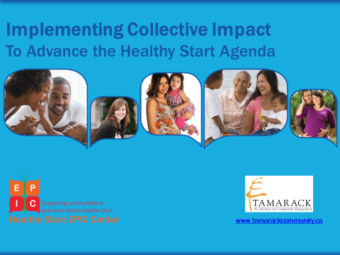**

**A Collective Impact Implementation Tool Box**

**For Healthy Start**

**March 2016**

TABLE OF CONTENTS

[Introduction 4](#_Toc444266347)

[SECTION ONE – Assessing Readiness and Context: The 3 Pre-Conditions of Collective Impact 7](#_Toc444266348)

[Assessing Readiness for Collective Impact 9](#_Toc444266349)

[The Collaboration Spectrum 11](#_Toc444266350)

[The Stakeholder Engagement Wheel 15](#_Toc444266351)

[The Community Reference System 18](#_Toc444266352)

[The Empathy Map Exercise 20](#_Toc444266353)

[Defining Our Issue 22](#_Toc444266354)

[Assessing our Collective Impact Resources 24](#_Toc444266355)

[Mapping Community Assets 27](#_Toc444266356)

[Mapping our Collective Impact Roles 31](#_Toc444266357)

[SECTION TWO - The Common Agenda 33](#_Toc444266358)

[Our Community Vision for Change 35](#_Toc444266359)

[Scoping Our Work: What’s In & What’s Out? 38](#_Toc444266360)

[Our Common Agenda Framework 40](#_Toc444266361)

[Assessing Readiness for Collective Impact 42](#_Toc444266362)

[SECTION THREE - Shared Measurement 44](#_Toc444266363)

[Shared Measurement Mapping 45](#_Toc444266364)

[The Collective Impact Outcomes Diary 49](#_Toc444266365)

[The Most Significant Change Tool 51](#_Toc444266366)

[SECTION FOUR - Mutually Reinforcing Activities 52](#_Toc444266367)

[Designing Your Mutually Reinforcing Activities 53](#_Toc444266368)

[Translating Strategy to Action Exercise 56](#_Toc444266369)

[Existing Programs & Services Inventory Exercise 57](#_Toc444266370)

[SECTION FIVE - Continuous Communications 58](#_Toc444266371)

[The 4 “M”s Effective Communications Tool 59](#_Toc444266372)

[SECTION SIX - Backbone Infrastructure 61](#_Toc444266373)

[Collaborative Governance Framework 63](#_Toc444266374)

[Collective Impact Initiative Budgeting Tool 65](#_Toc444266375)

[Planning Your Backbone Support 68](#_Toc444266376)

[SECTION SEVEN - Bringing it All Together 70](#_Toc444266377)

[Collective Impact Year I Action Plan Framework 70](#_Toc444266378)

[Year I Collective Impact Action Plan Summary 70](#_Toc444266379)

[Healthy Start Collective Impact PLN: CAN Action Plan Template 80](#_Toc444266380)

[APPENDIX 88](#_Toc444266381)

[Healthy Start Collective Impact Peer Learning Networks (CI-PLNs) 88](#_Toc444266382)

[The Healthy Start Peer Learning Journey 89](#_Toc444266383)

[Building Your Peer Learning Network 92](#_Toc444266384)

[Suggested Guidelines for Good Dialogue 96](#_Toc444266385)

[*Peerspirit* Circle Guidelines for Good Dialogue 96](#_Toc444266386)

[The Generative Star Relationship Tool 97](#_Toc444266387)

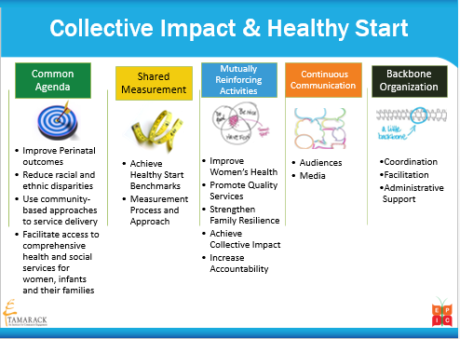Introduction

The **Healthy Start Collective Impact Implementation Tool Box** has been designed specifically to support Healthy Start grantees in effectively implementing a Collective Impact approach to realizing Healthy Start’s mission, “*To* *improve perinatal health outcomes and reduce racial and ethnic disparities by using community-based approaches to service delivery and facilitate access to comprehensive health and social services for women, infants and their families*.”

To fulfill this mission, Healthy Start grantees are required to develop and support Community Action Networks (CANs), and use a Collective Impact approach to work with their CANs to develop local implementation plans to achieve the five strategic goals of Healthy Start:

1. To improve women’s health

2. To promote quality services

3. To strengthen family resilience

4. To achieve collective impact

5. To increase accountability

The [**Healthy Start EPIC Center**](http://www.healthystartepic.org) has contracted with [**Tamarack – An Institute for Community Engagement**](http://www.tamarackcommunity.ca) to develop the **Healthy Start Collective Impact Implementation Tool Box**. To support the effective use of this tool box, six Peer Learning Networks – each co-facilitated by a Healthy Start Grantee and an EPIC Consultant – were created. Between April/May 2015 and December 2015, each Peer Learning Network convened 6-8 times and used the resources of the tool box to develop a Year I action plan. (See Appendix for more on the Peer Learning Networks).

***What is Collective Impact?***

[**Collective Impact**](http://c.ymcdn.com/sites/www.lano.org/resource/dynamic/blogs/20131007_093137_25993.pdf) is *“a disciplined, cross-sector approach to solving complex social and environmental issues on a large scale.”* First defined by John Kania and Mark Kramer of [**FSG: Social Impact Consultants**](http://www.fsg.org)in an article published in the [**Stanford Social Innovation Review**](http://www.ssireview.org/articles/entry/collective_impact) in 2011, Collective Impact (CI) includes five conditions and three pre-conditions which, when applied in a comprehensive way, have demonstrated remarkable effectiveness in addressing a broad range of issues. Collective Impact has garnered rapid uptake, in part due to the clear and elegant way that Kania and Kramer describe its collaborative, multi-sector approach. Collective Impact is also very much an evolving body of practice whose effectiveness is being accelerated as the growing number of practitioners who are now implementing it share their insights and experiences.

***Overview of the Tool Box***

The resources and tools within this toolbox do not provide an exhaustive list of options within each topic area, rather the tools shared here have been selected because they are clear and straightforward to use and also encourage the thinking and conversations that are ultimately needed to develop the richer, shared understanding of a common issue among people with a diversity of perspectives.

The popularity of Collective Impact as a promising approach for addressing complex community issues has sparked uptake of its application. As a result, the field is growing rapidly and new resources and tools are continuously being developed and refined. We fully anticipate the learning generated by Healthy Start grantees through this process will lead to refinements and enhancements as well. For these reasons, it is best to consider this tool box to be a “living document.” Your input regarding opportunities to enhance the tools featured here, or add to the tool box with additional useful tools used by grantees and their CANs is valued and welcomed.

We look forward to working together with you to refining this document as a resource that will accelerate the effectiveness of Healthy Start Grantees in applying Collective Impact.

**There are seven sections in the Healthy Start Collective Impact Implementation Tool-Box:**

**Section 1 – Assessing Readiness and Context: The Pre-Conditions:** These tools and resources assist participants to assess the current context of the community and their Healthy Start initiative using the lens of Collective Impact.

* + - **Section 2 – The Common Agenda:** These tools and resources are focused on scoping, defining and affirming the common agenda for your work.
    - **Section 3 – Shared Measurement:** These tools and resources explore shared measurement for your Healthy Start CI Initiative, and shared measurement systems to monitor and inform your strategy.
    - **Section 4 – Mutually Reinforcing Activities:** The tools and resources in this section focus on how to align resources across the engaged partners into an initial theory of change that you and your partners believe will enable you to achieve your common agenda.
    - **Section 5 – Continuous Communication:** These tools and resource focus on exploring ways to coordinate and champion the work that you and your partners are undertaking together.
    - **Section 6 – Backbone Infrastructure:** The tools and resources in this section focus on the essential structures and agreements needed to facilitate good coordination across the multiple partners engaged in your Collective Impact effort.
    - **Section 7 – Bringing it All Together: The Year I Action Plan:** The primary resource in this section is the framework for creating a Year I Collective Impact Implementation Plan for Healthy Start grantees.

The tool box also includes an appendix on **Building Your Peer Learning Network.** These resources focus on the work of building, and sustaining, a dynamic Collective Impact Peer Learning Network.

Each section follows a consistent format:

* **Overview –** This frames the purpose and intent of the topic or Collective Impact condition featured in the section;
* **Tools –** This is the primary content – including tools and worksheets – that Healthy Start grantees can use to explore the section’s topic or CI condition;
* **Resources for Going Deeper** – This is where you will find links, articles, audio seminars and videos that can be used and shared, for those interested in diving deeper into the content and ideas presented in the section.

SECTION ONE – Assessing Readiness and Context: The 3 Pre-Conditions of Collective Impact

**Overview**

There are three pre-conditions of Collective Impact: Influential Champions; Urgency of Issue; and Adequate Resources. Together, these pre-conditions identify three community elements that determine the success of a Collective Impact effort. A good assessment of these elements enables groups to undertake the groundwork needed to build awareness, and ultimately momentum, around an issue. The three pre-conditions are defined below:

• **Influential Champions**: Are influential community champions drawn to the issue and willing to commit their collective resources and networks to move the issue forward?

• **Urgency of the Issue**: Does the community perceive the issue to be both important and urgent? What data are required to gain greater clarity about the issue?

• **Adequate Resources**: What resources are required to ensure that the partners have sufficient capacity to move the issue forward? These can include resources for convening meetings, research, and community engagement in this early phase.

**Tools for Assessing Readiness and Context**

***Influential Champions***

1. **Assessing Readiness for Collective Impact Tool** – This short assessment tool can be used to assess readiness of potential partners to embrace CI as a framework for their community change effort.
2. **The Collaboration Spectrum Tool** - The Collaboration Spectrum is useful to explain and distinguish Collective Impact as a form of collaboration.
3. **Top 100 Partners** – This exercise is used to engage participants in a brainstorm, and prioritize influential leaders who you can engage in your CI effort
4. **The Stakeholder Wheel of Engagement** – This tool is used during face-to-face meetings to allow participants to indicate their preferences regarding the degree – and also specific areas – that they would like to continue to be engaged in your work.
5. **The Community Reference System** – This is an alternative community engagement strategy and process. It is ideally suited for identifying, and justifying, who to invite to a gathering when numbers are limited.

***Urgency of Issue***

1. **The Empathy Map** – This tool/exercise is useful in encouraging participants to consider the perspectives of other key stakeholders and/or recipients of the initiative.
2. **Defining Our Issue –** This tool invites you to define your issue and its intended impact in as concrete a way as possible.

***Adequate Resources***

1. **Assessing our Collective Impact Resources** – This tool offers a guide to identify and record the full scope of resources available to be mobilized in support of your Collective Impact effort, and also to assess and identify resource gaps.
2. **Mapping Community Assets**- This tool can be used to map community services and programs for women, children and families, and to identify potential service gaps.
3. **Mapping Our Collective Impact Roles** – This tool can be used to identify and map the individuals engaged in your collective impact effort, the roles that each plays and also identify recruitment needs.

**Resources for Going Deeper: Assessing Readiness and Context**

* [**Collective Impact**](http://www.ssireview.org/articles/entry/collective_impact), *John Kania and Mark Kramer, Stanford Social Innovation Review, Winter 2011*. This article is the best starting point for developing an understanding of Collective Impact.
* [**Channeling Change: Making Collective Impact Work**](file:///C:\Users\Sylvia\Dropbox\Tamarack%202015%20Work\Custom%20Consulting\Healthy%20Start%20-%20VA\CI%20Capacity-Building%20Contract\CI%20Implementation%20Tool-Kit\•%09http:\www.ssireview.org\blog\entry\channeling_change_making_collective_impact_work), *John Kania and Mark Kramer, Stanford Social Innovation Review, 2012.*  This article offers a deeper look at examples of Collective Impact in action and implementation steps.
* [**Embracing Emergence:** **How Collective Impact addresses Complexity**](http://www.ssireview.org/blog/entry/embracing_emergence_how_collective_impact_addresses_complexity), *John Kania and Mark Kramer, Stanford Social Innovation Review, January 2013*. This article explores how Collective Impact responds to the complex dynamics of community change.
* [**Tamarack Resource @ a Glance: Collective Impact**](http://tamarackcci.ca/files/resource_at_a_glance_collective_impact_1_0.pdf) – This 2-page resource gives a summary overview of Collective Impact.
* **Healthy Start Introduction to Collective Impact** PowerPoint presentation on healthystartepic.org

Assessing Readiness for Collective Impact

**EXERCISE DESCRIPTION:**

Convening a collaborative community change effort can be challenging. The White House Council on Community Solutions evaluated 12 Collective Impact initiatives, and identified a set of five questions which community partners need to consider to assess their readiness to embrace Collective Impact as the framework that makes the most sense for what they are trying to achieve.

List of framing questions:
Do we aim to effect-needle change (i.e. significant and measurable progress) on a community-wide metric?
Do we believe that a long-term investment (i.e. three to five-plus years) by stakeholders is necessary to achieve success?
Do we believe that cross-sector engagement is essential for community-wide change?
Are we committed to using measurable data to set the agenda and improve over time?
Are we committed to having community members as partners and producers of impact? The first five questions on this worksheet come from the [White House Council on Community Solution’s Community Collaboratives Toolbox](http://www.aspeninstitute.org/sites/default/files/content/docs/resources/White_House_Council_For_Community_Solutions_Tool_Kit.pdf). These five questions can be used as a diagnostic tool for project leaders to identify areas where their work can be strengthened. They can also be used as an assessment tool with boards and organizational partners to assess readiness to embrace Collective Impact as a framework. Experience suggests that if a group finds itself unable to say yes to at least three of the five questions, more groundwork may be needed to create shared readiness to embrace a full Collective Impact approach.

If it decided that applying a Collective Impact approach DOES make sense, it is important that partner organizations ensure internal understanding and support for engaging in a Collaborative process by thoughtfully considering both the risks and rewards of such involvement.

**EXERCISE HOW-TO:**

1. Invite people to complete this questionnaire/poll individuals. This can even be done electronically.
2. Tabulate responses and share the results.
3. Use the responses as a starting point for more in-depth discussion and understanding.

**EXERCISE DEBRIEF:**   
If you have consensus on fewer than three of the five questions, it is likely that you do not have the necessary support to undertake a full Collective Impact approach. However, the results can be useful in informing and focusing your community education and engagement efforts.

**Collective Impact Framing Questions Worksheet**

| **Collective Impact**  **Framing Questions** | **Strongly Disagree 1** | **Disagree 2** | **Neutral 3** | **Agree4** | **Strongly Agree5** | **Don’t Know**  **N/A** |
| --- | --- | --- | --- | --- | --- | --- |
| 1. Do we aim to effect ―**needle-change** (i.e., 10% or more) on a community-wide metric? | blank | blank | blank | blank | blank | blank |
| 1. Do we believe that **a long-term investment** (i.e., three to five-plus years) by stakeholders is necessary to achieve success? | blank | blank | blank | blank | blank | Blank |
| 1. Do we believe that **cross-sector e**ngagement is essential for community-wide change? | blank | blank | blank | blank | blank | blank |
| 1. Are we committed to **using measurable data** to set the agenda and improve over time? | blank | blank | blank | blank | blank | blank |
| 1. Are we committed to having **community members as partners** and producers of impact? | blank | blank | blank | blank | blank | blank |
| **Assessing the Risks and Rewards of Engaging in a Collective Impact Effort** | | | | | | |
| **Reputational Impact** – Will our organizational reputation be enhanced or damaged by our involvement in this partnership or if the partnership fails? | blank | blank | blank | blank | blank | blank |
| **Loss of Autonomy:** Are we comfortable if working collaboratively means that there may be less organizational independence in areas of joint work? | blank | blank | blank | blank | blank | blank |
| **Conflict of Interest:** Are we prepared for times when our organization may be pushed to settle for an uncomfortable compromise or be required to support a policy which it does not agree with? | blank | blank | blank | blank | blank | blank |
| **Drain on Resources**: Are we comfortable with the fact that partnerships typically require a heavy front end investment (of time and human capital) in advance of any return? | blank | blank | blank | blank | blank | blank |
| **Implementation Challenges:** Are we prepared to continue our involvement in the face of challenges (such as moving from planning to implementation)? | blank | blank | blank | blank | blank | blank |

The Collaboration Spectrum

Image reads in order of collaboration spectrums as follows. 
1) Compete: Competition for clients, resources, partners, public attention
2) Co-exist: No systematic connection between agencies
3) Communicate: Inter-agency information sharing (e.g. networking).
4) Cooperate: As needed, often informal, interaction, on discrete activities or projects.
5) Coordinate: Organizations systematically adjust and align work with each other for greater outcomes
6) Collaborate: Longer term interaction based on shared mission, goals; shared decision makers and resources
7) Integrate: Fully integrated programs, planning, funding.

Instructions at the bottom of the image:
Have collaborative members individually assess where they think the collaborative is on the spectrum.
Are you all in the same place or in different places? Do you want to move to a new place? 
Have a discussion about this.

**EXERCISE DESCRIPTION:**

The word ‘collaboration’ can be interpreted in many different ways. There is a continuum of different collaborative approaches. As groups move along the continuum they must pay attention to activities that build trust among the partners. Collective Impact efforts exist within the stages of the collaboration continuum that include coordination of efforts, collaboration among partners and the integration of services and programs. ***What distinguishes Collective Impact as a form of collaboration is its unique emphasis on the use of shared data, and its focus on working together across multiple sectors.***

**EXERCISE HOW-TO:**

1. Ask participants to place a colored dot on a visual of the *Collaboration Spectrum* to depict the level of collaboration **currently** happening regarding your issue.
2. You can also ask them to place a second different color dot on the *Collaboration Spectrum* to depict the level of collaboration that they personally would like to see in addressing your issue.
3. Debrief and discuss similarities and differences reflected in the placement of dots.

**EXERCISE DEBRIEF:**

Some suggested debrief questions include:

* How can we get others excited to work with us on this issue?
* What additional information do community partners require (and who should they hear it from)?
* Do we have this information? If not, where can we find it?

**The Collaboration Spectrum Worksheet**

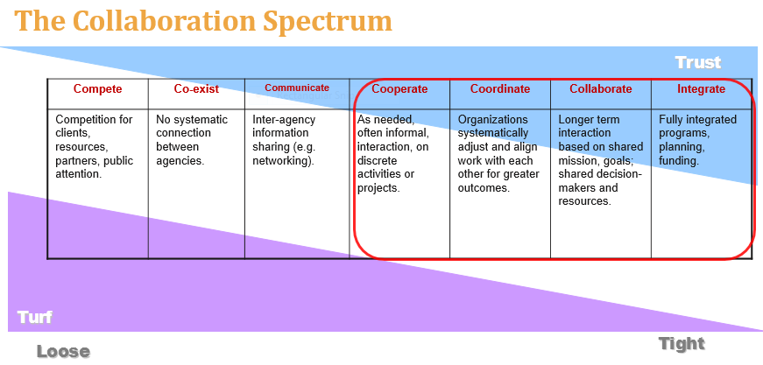

| **CURRENT LEVEL OF COLLABORATION:**  Place a **blue** **dot** on the *Collaboration Spectrum* to indicate the **current** level of collaborationregarding our issue. Jot down a few points about how you reached your assessment: What are you seeing/not seeing? |
| --- |
| **IDEAL LEVEL OF COLLABORATION:**  Place a **green dot** on the *Collaboration Spectrum* to indicate the **ideal** level of collaboration that you would personally like to see**.**  Jot down your thoughts and ideas regarding your assessment. |

**Top 100 Partners Worksheet**

**Who are the top 100 people that “if they agreed, things would change” who we need to engage to work with us?**

* **Goal:** Comprehensive System Engagement
* **Challenge Today:** Identify the key “door openers” to each sector in the system.
* **Our Top 100:** The 100 people that, if they bought into our change effort, we are confident that change would occur.
* **Next Steps:** Build a database of those we most desire to engage with the constituency or issue we represent. Host conversations for system-wide engagement and develop a communications system that keeps them linked to our work.

| **Business Sector**  ***Share organizations, names and titles*** | **Government or Public Sector**  ***Share organizations, names and titles*** |
| --- | --- |
| blank  blank | blank |
| **Citizens/Lived Experience**  ***Share organizations, names and titles*** | **Voluntary/Charitable/Non-Profit Sector**  ***Share organizations, names and titles*** |
| blank | blank |

**Ranking Our Top 100**

| **WHO** | **ABILITY to Help**  ***The Reason*** | **ABILITY to Help**  ***Ranking*** | **WILL to Help**  ***The Reason*** | **WILL to Help**  ***Ranking*** | **NOTES** |
| --- | --- | --- | --- | --- | --- |
| blank | blank | blank | blank | blank | Blank |
| Blank | Blank | Blank | Blank | Blank | Blank |
| Blank | Blank | Blank | Blank | Blank | Blank |
| Blank | Blank | Blank | Blank | Blank | Blank |
| Blank | Blank | Blank | Blank | Blank | Blank |
|  | Blank | Blank | Blank | Blank | Blank |
| blank | Blank | Blank | Blank | Blank | Blank |
| blank | Blank | Blank | Blank | Blank | Blank |
| Blank | Blank | Blank | Blank | Blank | Blank |
| Blank | Blank | Blank | Blank | Blank | Blank |
| Blank | Blank | Blank | Blank | Blank | Blank |
| Blank | Blank | Blank | Blank | Blank | Blank |
| Blank | Blank | Blank | Blank | Blank | Blank |
| Blank | Blank | Blank | Blank | Blank | Blank |
| Blank | Blank | Blank | Blank | Blank | Blank |
| Blank | Blank | Blank | Blank | Blank | Blank |
| Blank | Blank | Blank | Blank | Blank | Blank |
| Blank | Blank | Blank | Blank | Blank | Blank |
| Blank | Blank | Blank | Blank | Blank | Blank |
| Blank | Blank | Blank | Blank | Blank | Blank |
| Blank | Blank | Blank | Blank | Blank | Blank |
| Blank | Blank | Blank | Blank | Blank | Blank |
| blank | blank | blank | blank | blank | blank |
| For more information on this tool see ***Community Conversations*** by Paul Born – pages 117-126. | | | | | |

The Stakeholder Engagement Wheel

**EXERCISE DESCRIPTION:**

This worksheet is a useful way to engage attendees at a workshop or presentation to quickly and easily provide you with input regarding their own desired level of involvement in the opportunities and work of your group going forward. If needed, the circle can be sub-divided into slices, each of which represents specific “priority areas” related to your group’s work. These can then be specifically identified on the visual. Descriptions of the “levels of involvement” on the graphic – as well as definitions of each priority area –can be described on the back page.

It can be most useful to introduce this tool after participants have had an opportunity to identify concrete and specific opportunities for action to advance a strategy. Specifically you can ask that they identify the 3-5 high leverage strategies for this priority area within the next year. People tend to be more comfortable placing themselves on the stakeholder wheel when they have a fairly concrete sense of the potential focus of work for the various groups.

**EXERCISE HOW-TO:**

**Time Needed:** 5 minutes to set up and 5 minutes to complete

**Instructions:**

* Ask people to place a dot (or dots) to indicate the level of involvement they would like to have in the continuation of putting the ideas explored today into action
* Take a few moments to summarize at a high level how each level of engagement is defined, and let them know that the definitions can be found on the back of the worksheet.
* If applicable, recap the priority areas for action and let people know that descriptions of those priority areas can also be found on the back of the worksheet.
* Tell people they are welcome to place more than one dot on their map, to represent different levels of involvement with different aspects of the project’s work.
* Remind people to be sure their name and contact information is written on the bottom right corner of the worksheet.

**EXERCISE DEBRIEF:**Participants are invited to turn in their completed form, but no debrief of this worksheet is typically needed.

**Stakeholder Engagement Wheel Worksheet**

**Core**

**Involved**

**Supportive**

**Interested**

**Name:**

**Organization: ­­­­­­**

**Title:**

**Phone Number:**

**Email Address:**

**Area of Involvement:**

**□ Overall Initiative**

**□ □ Specific Area: \_\_\_\_\_\_\_\_\_\_\_\_\_\_\_\_\_\_\_\_\_\_\_**

**Stakeholder Engagement Wheel**

**Levels of Involvement Descriptions**

**Core** - Stakeholders or individuals who are interested in being actively involved in the functioning and development of a Collective Impact effort to enhance community well-being in your community. (e.g. becoming members of the Working Group – meeting regularly; helping to develop sections of the plan).

**Involved** - Stakeholders or individuals who want to be frequently consulted and given opportunities to provide in-depth feedback. (e.g. attending topic specific/community specific/age specific discussions or workshops).

**Supportive -** Stakeholders or individuals who provide some form of support and input (e.g. attending future community forums, answering surveys or providing input online).

**Interested** - Stakeholders or individuals who are kept informed of the progress of the initiative, but are not directly involved in the work (e.g. listserve, newsletter, informed about opportunities to participate in events).

The Community Reference System

**EXERCISE DESCRIPTION:**

The *Community Reference System* – developed by Fred and Merrelyn Emery – is a highly participative way to engage a community in helping to select who attends a learning event or gathering on their behalf. Put another way, it’s a process to allow a community to determine the participation of its own members. The *Community Reference System* is an effective way to build awareness and “buzz” about your gathering, and is best used when:

* It is not possible to invite an entire group to a particular event – when the number of participants for a particular session has to be limited.
* There may be questions asked about how participants were chosen for an event.
* A group’s work must have credibility or the environment is highly political and cynicism around an event’s legitimacy needs to be diffused.
* The process of involving a broader subset of the community to identify participants can help build awareness and enthusiasm for the event itself.

**EXERCISE HOW-TO:**

**Instructions:**

1. Brainstorm a list of names for each sector of individuals known to be concerned about your issue or opportunity. Typical criteria include:
   * The process would not have credibility unless this person was involved
   * The person has a reputation for speaking about this issue
   * The person is well-respected in the neighborhood
   * The person is available and willing to participate
   * The person is likely to be willing to do work in support of your issue
2. Make sure you have generated at least one or two names for each sector on the community map, and identify at least one individual within each of the components of the social map.
3. These initial individuals are contacted, and asked to recommend two or three people from within their sector who meet the criteria. (Sometimes a script is developed)
4. The recommended people are then contacted and also asked to make two or three recommendations. After two or three iterations, the same names should begin to appear on the list.
5. From this total list of possible participants, select people whose names have been repeated, and add participants to ensure that all perspectives identified on the rough social map are represented. Then contact and invite these individuals.

For more information see: [**Resource at a Glance: The Community Reference System**](http://tamarackcci.ca/resource-library/community-engagement/resource-glance-community-reference-system)

**The Community Reference System Worksheet**  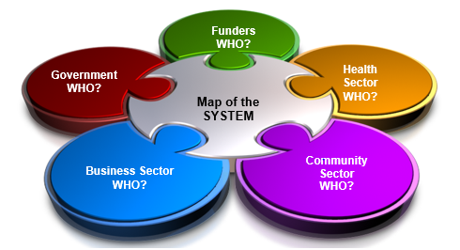

| **Our Community Reference System** | | | |
| --- | --- | --- | --- |
|  | **Contact** | **Sector** | **Contacted By:** |
| **Initial Contacts** | blank | blank | blank |
| **Round #1 Recommendations** | blank | Blank | Blank |
| Blank | Blank | Blank |
| Blank | Blank | blank |
| Blank | Blank | Blank |
| Blank | Blank | Blank |
| Blank | Blank | Blank |
| blank | blank | blank |
| **Round #2**  **Recommendations** | Blank | blank | blank |
| Blank | blank | blank |
| blank | blank | blank |
| blank | blank | blank |
| blank | blank | blank |
| blank | blank | blank |
| **Selected Invitees** | Blank | Blank | blank |
| Blank | Blank | blank |
| Blank | blank | Blank |
| Blank |  | blank |
| Blank | blank | blank |
| Blank | blank | blank |
| blank | blank | blank |

The Empathy Map Exercise

**EXERCISE DESCRIPTION:**

This exercise is intended to help you to consider the perspectives of the people your project serves or affects. Empathy maps can be created about hypothetical users or customers to better focus on their experience of the project or service. Empathy maps can be completed byindividuals or as a team. Developing empathy maps for varied and contrasting hypothetical users can really round out your understanding of user experience. When you can, invite real live stakeholders to complete first-person empathy maps!

Developing an empathy map helps your team to consider the many forces around your users and customers that affect their experiences. Post the empathy maps where the team can see them daily.

**EXERCISE HOW-TO:**

**Time required:** 30 minutes

**Instructions:**

1. Choose a name, sex and age for the hypothetical person/user. Do they have a job, a family or something else distinctive about their daily life? Jot these characteristics down on the edge of the map.
2. Put yourself in that person's shoes and think about their experience of your project/service:
   1. What are they seeing?
   2. What are they saying?
   3. What are they doing?
   4. What are they thinking?
   5. What are they feeling?
3. Answer all six questions on the map in as much detail as you can imagine.
4. After you have completed your empathy map, list:
   1. 3 things that this person wants; and,
   2. 3 obstacles to those desires.

**EXERCISE DEBRIEF:**

Possible debrief questions:

* How do we need to refine the engagement, design or delivery of our work based upon the insights generated from our empathy map?
* What’s have we learned here that can help us build, and retain, trust among those involved?

**The Empathy Map Exercise Worksheet**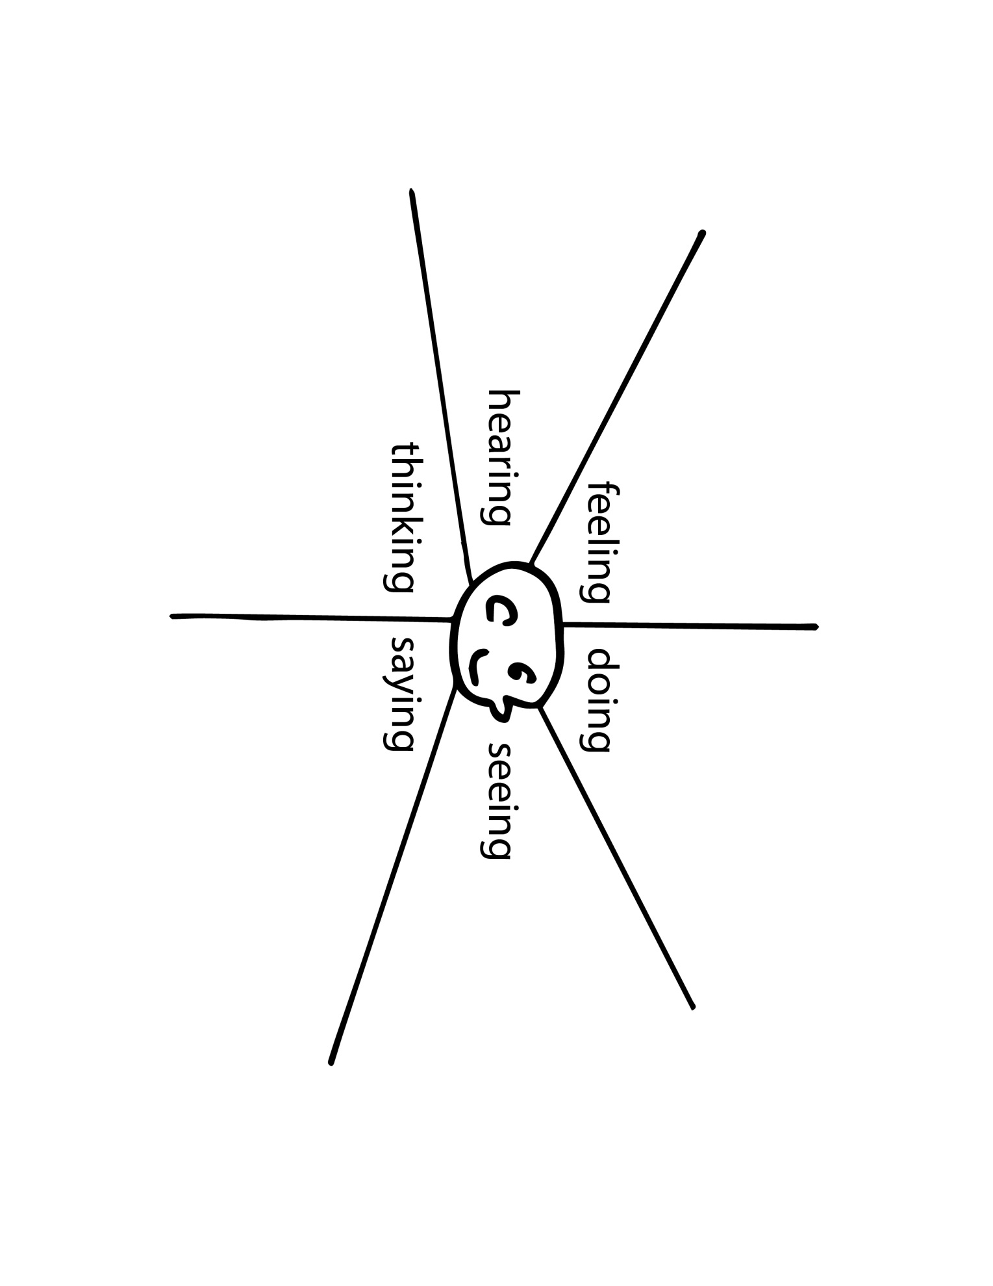

Defining Our Issue

**EXERCISE DESCRIPTION:**

This tool invites you to think about the critical work of clarifying, and reaching agreement on, the scope and reach of your Collective Impact initiative. While it is important and useful to ensure there is agreement among your partners regarding what IS and IS NOT included within the scope of your intended work, it is equally important to remember, that from time to time it may be necessary to revisit and challenge or reaffirm your original scope, either in response to a changing community environment, or in light of unexpected opportunities or challenges.

**EXERCISE HOW-TO:**

1. Complete the worksheet either individually or in small groups. As much as you can, strive to ensure that your definition is clear, concrete and measureable.
2. If outcomes and/or measure already exist for the issue, be sure to write these up in advance.
3. Be sure to identify and be up front with potential community partners about parameters that cannot be changed.

**EXERCISE DEBRIEF:**

Possible debrief questions include:

* **Re: Our Issue**
  + How clearly have we defined our issue?
  + Have we identified the specific impact we hope to have regarding our issue?
  + What else would help us better define our impact?
* **Re: Outcomes & Measures** 
  + What outcomes and measures already exist?
* **Re: Opportunities** 
  + Is there consensus re: opportunities to be leveraged?
  + What initial actions can be taken to leverage these opportunities? By whom?
* **Re: Barriers**
  + Where do we see opportunities to overcome identified barriers?
  + What initial actions can be taken to leverage these opportunities? By whom?

**Defining Our Issue Worksheet**

| **Our Issue:** | |
| --- | --- |
| **Outcomes and Measures:** | |
| **What opportunities for change in our community can we leverage?** | **What barriers currently exist to prevent that change?** |

Assessing our Collective Impact Resources

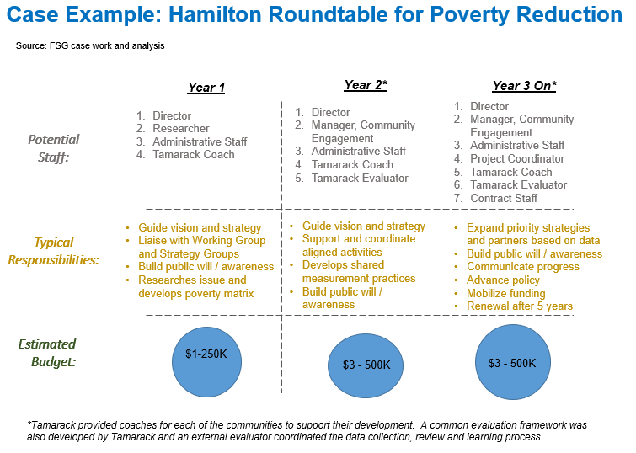 **EXERCISE DESCRIPTION:**One of the three pre-conditions of Collective Impact is **Adequate Resources.** Certainly funding is an important dimension of resourcing Collective Impact. However the resources needed for a robust Collective Impact effort also include human resources, services, and goods.

The graphic to the right offers an example of the primary resources needed for a CI effort.

**EXERCISE HOW-TO:**

Use the worksheet to document both the resources that you have, and the resources you need.

**EXERCISE DEBRIEF:**

Debrief questions can include:

* What actions do we need to take based upon our analysis?

**Assessing our Collective Impact Resources Worksheet**

**Our Collective Impact Goal: \_\_\_\_\_\_\_\_\_\_\_\_\_\_\_\_\_\_\_\_\_\_\_\_\_\_\_\_\_\_\_\_\_\_\_\_\_\_\_\_\_\_\_\_**

**What do we HAVE to support our Collective Impact effort?**

**Resources: What do we NEED to support our Collective Impact effort?**

Mapping Community Assets

**EXERCISE DESCRIPTION:**

This worksheet will help your collaborative group to identify the breadth of community services and programs that currently exist to serve pregnant women, children, and young families. The community mapping exercise is an important step in understanding what services and programs, both formal and informal, already exist to support pregnant women, children, and young families, and also to identify potential gaps in service delivery. It is also an opportunity for the collaborative group to identify how each member is connected to this network of community service or programs and/or where there might be connection gaps.

Image of a post-it note with the following text:

Name of program or service:
Smiling Tots Childcare

Serves: Children 18 mos - 5 years, 32 spaces available

Notes: Has a strong Parent Council and actively involves the local community through workshops and parent/child reading programs.

Connection: Sarah Smith is a member of the Parent Council.

**EXERCISE HOW-TO:**

1. Provide each member of your collaborative network with 10 -15 sticky notes.
2. Invite participants to spend a few moments filling out the sticky notes with community-based, state and federal programs and services that are supporting children and their families. A separate sticky note should be used for each program or service.
3. Each sticky note should contain the following information:
   * Name of the program or service
   * Who the program serves: specific population
   * Notes about the program or service
   * Connection of the collaborative to the program or service
4. Once the individual participants have completed their sticky notes, gather the group together around a long open wall or multiple flip chart papers.
5. Invite individuals to share the programs and services that they identified.
6. Ask the group to consider how to group these programs and services together. Common groupings might include services of a similar type (e.g. childcare centers, education program), services that support a particular population (e.g. babies, children to 3 years, parents, etc.) or services that deliver a particular program (e.g. reading programs, afterschool programs).
7. Once everyone has posted their sticky notes, ask the group to step back and look at the picture as a whole. Ask the following questions:

* What do you see?
* Where are our community strengths? Where are our weaknesses?
* If we wanted to improve outcomes for women, children and families, where could we start?
* Are there any possible leverage points for us to consider?
* What are the gaps that we see in services and programs?
* What else do we need to consider?

Capture the notes from this conversation.

1. Take a picture of the community map. This will provide a good starting point for understanding who is doing what in the community, and how the collaborative partners are already connected.

To go deeper with this exercise, use the community map that has been developed to draw connections between the different programs and services that have been identified.

Making Connections:

* Solid lines between two or more programs or services mean that those programs and services are already connected together and have strong ties (for example: the programs and services share space, or conduct joint activities)
* Dotted lines between two or more programs and services mean that the programs and services are more weakly connected (for example: the programs and services staff might participate on a network committee that meets infrequently)

Geographic Maps:

* Identify where community programs and services are located in the community on a street or community map. This can help the collaborative understand the specific location of different programs and services and how accessible they might be to clients and stakeholder.

**EXERCISE DEBRIEF:**

Some suggested debrief questions include:

* What does our community map tell us about how women, children and families are currently being supported in our community?
* What additional information do we need, and from whom?
* Do we have this information? If not, where can we find it?

**EXAMPLES OF COMMUNITY/SERVICES ASSET MAPS:**

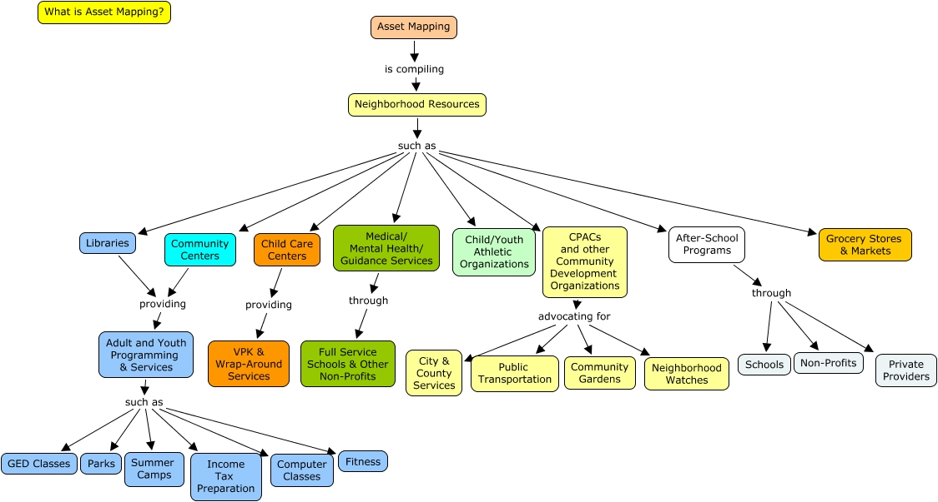

Link - [Community Asset Map](http://happy.unfcsd.unf.edu/rid=1P9Y9KBR9-1KMSPQ3-7X/Asset%20Mapping.cmap)

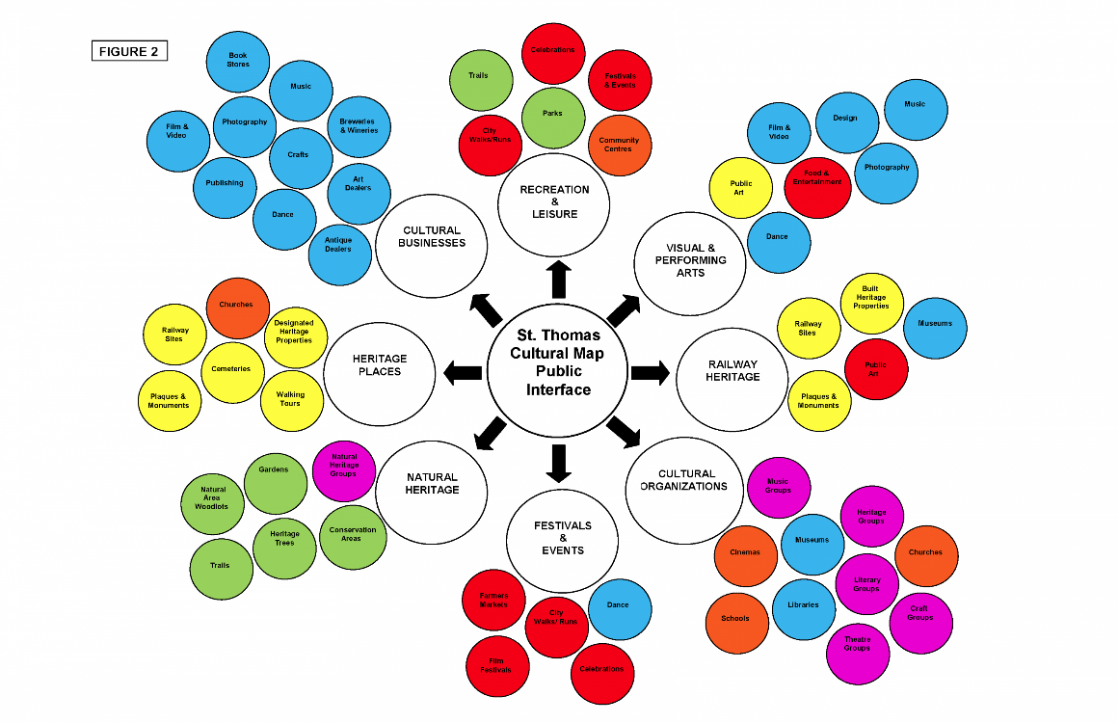

Link - [City of St. Thomas Cultural Map](http://stthomas.ca/sites/stthomas.civicwebcms.com/files/media/CulturalMapping/St.%20Thomas%20Cultural%20Map%20Public%20Interface_0.png)

**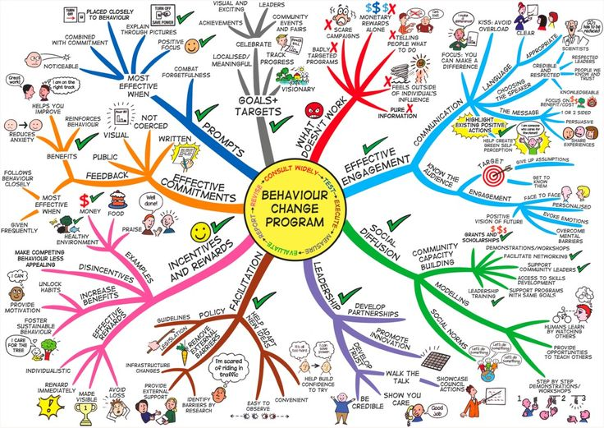**

Link - [Behaviour Change Program Map](http://www.mindmapart.com/behaviour-change-mind-map-jane-genovese/)

Mapping our Collective Impact Roles

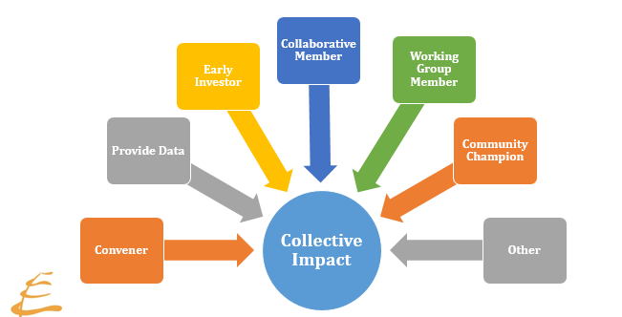

**EXERCISE DESCRIPTION:**

The visual above depicts a range of potential roles within a Collective Impact initiative. This exercise is designed to assess how best to utilize the skills of your team, volunteers and other partners. It also helps to identify human resource gaps and enable you to consider options to strategically recruit new talent. This assessment is certainly an important one at the start of a new initiative, but it is also particularly valuable to undertake at key points of renewal within the lifecycle of a Collective Impact effort. Experience suggests that it is most helpful if leaders think of their Collective Impact effort as 3-5 year campaigns to proactively encourage regular renewal.

**EXERCISE HOW-TO:**

Ask your leadership group to:

1. Consider the current Collective Impact effort, and determine any additional roles needed to implement the work of the CI effort, and add those roles to the visual.
2. Use sticky notes to populate the visual of roles with the names of individuals and/or organizations now engaged in the Collective Impact initiative.
3. Assess current strengths and weaknesses, and generate a strategy to strategically fill gaps.

**EXERCISE DEBRIEF:** Participants are invited to turn in their completed forms, but no debrief of this worksheet is typically needed.

**Mapping our Collective Impact Roles Worksheet**

**Assessing Our Team Regarding Collective Impact Roles**

Your team should consider the roles that need to be filled to successfully implement your plan. Assess your current strengths and weaknesses and brainstorm strategies to strategically engage and recruit candidates to fill gaps. Be sure to think long term, not just for a single year.

| **Role** | **Current Strengths/ Weaknesses** | **Who Can Fill  this Role?** | **Next Steps** |
| --- | --- | --- | --- |
| **Convener** | blank | blank | blank |
| **Data Provider & Analyst** | blank | blank | blank |
| **Early Investor** | blank | blank | blank |
| **Collaborative Member**  **(lived experience)** | blank | blank | blank |
| **Working Group Member**  **(lived experience)** | blank | blank | blank |
| **Community Champion** | blank | blank | blank |
| **Other?** | blank | blank | blank |

SECTION TWO - The Common Agenda

**Overview**

There are a number of factors to consider when working to build a common agenda for your community issue. These include:

* Understanding the prior history of collaboration in your community
* Determining whether the issue is pressing
* Understanding what data are required and who has the data relevant to the issue
* Understanding your community context (community system)
* Building a core group of interested individuals
* Recruiting an influential organization to convene community conversations
* Developing a broader community engagement strategy

Many of these factors have initially been addressed in *Section One: Assessing Readiness & Context* which focused on deepening understanding of the three pre-conditions of Collective Impact.

Beyond a shared vision, a common agenda includes not only a definition of a shared issue that partners across multiple sectors intend to address together, but it also includes the partners’ shared understanding of that issue, and their agreed-upon approach for how best to address it. Many inspiring common agendas have an aspirational quality when they are ultimately articulated.

Those working to define a common agenda need to anticipate that the process will be an iterative one. Feedback and input from continuous community engagement needs to be used to assist the initiative’s leaders to polish and refine their articulation of the common agenda. Key elements that are incorporated into a common agenda statement include:

* A Description of the Problem (informed by research)
* Clear Goal for Change (ideally measureable)
* A Portfolio of Strategies that focus on driving large scale change
* A Set of Principles that guide the group’s behaviors
* An Approach to Evaluation that frames strategy for receiving and integrating feedback

**Common Agenda Tools**

1. **Our Community Vision for Change** – This tool can be used, individually or in groups, to allow people to envision the positive future they want to create.
2. **Scoping Our Work: What’s In & What’s Out?** – This tool invites you to think about the critical work of clarifying, and reaching agreement among your initiative’s leadership, regarding the scope of your Collective Impact work.
3. **Our Common Agenda Framework** – This tool invites you to view your common agenda within a holistic context, inviting dialogue to explore and clarify the key elements that ultimately help to define your common agenda.
4. **Assessing Readiness for Collective Impact Tool** – This short assessment tool can be used to assess the readiness of potential partners to embrace CI as a framework for their community change effort.

**Resources for Going Deeper: The Common Agenda**

* **Healthy Start Introduction to Collective Impact** PowerPoint presentation on healthystartepic.org

Our Community Vision for Change

**EXERCISE DESCRIPTION:**

A shared vision answers the question: ***What do we want to create?*** It creates a sense of commonality, builds trust among people, and gives coherence to diverse activities. When truly shared, visions spark energy and creativity, and encourage risk-taking and innovation. Powerful shared visions emerge from people’s own personal visions. A personal vision answers the question: ***What do I really want?*** The only vision that can truly motivate a person is his or her own.

The process of building a shared vision is important and the time spent thinking and talking about a vision is as important as what is finally written down. This is because it enables people to build shared meaning about what’s important and why. It also allows them to develop a common identity and sense of common purpose. The most powerful visions reflect many people’s personal visions.

**EXERCISE HOW-TO:**

1. Ask people to draft their own personal vision in words or images – whatever comes to them.
2. Invite people to pair up and share their visions with each other, listening for commonalities and also unique elements that inspire them.
3. Invite the whole group to share key elements of their shared visions.
4. Based upon this vision, invite people to identify the important levers for change needed to make their emerging vision a reality. Consideration of these levers will be important in defining your group’s common agenda.

**EXERCISE DEBRIEF:**

After people’s individual visions have been shared, ask the group to reflect on the following questions:

* What are the common elements that unite our individual visions?
* What unique ideas did you hear in other people’s visions that inspired you?
* Is there anything within what you’ve heard in these visions that you COULD NOT support?
* Can we assume that we all agree that all else is endorsed by all?

**Our Community Vision for Change Worksheet**

**What is our vision for creating a community where all infants, and their families, thrive?**

**What needs to change to realize our community vision?**

| **Type of Change** | **Priorities for Change in our Community** |
| --- | --- |
| ***Systems*** | blank |
| ***Institutions or Organizations*** | blank |
| ***Resources*** | blank |
| ***Relationships*** | blank |

Scoping Our Work: What’s In & What’s Out?

**EXERCISE DESCRIPTION:**

This exercise invites you to think about the critical work of clarifying, and reaching agreement on, the scope and reach of your Collective Impact initiative. While it is important and useful to ensure there is agreement among your leadership regarding what IS and IS NOT included within the scope of your intended work, it is equally important to remember, that from time to time it might be necessary and or important to revisit and challenge or reaffirm your original scope, either in response to a changing community environment, or in light of unexpected opportunities or challenges.

**EXERCISE HOW-TO:**

1. Invite participants to use sticky notes to identify things that they know for sure are either in or out of the current scope of work.

1. Use a different color of sticky note to identify potential boundaries that are still being questioned.
2. Review the aspects of your scope that still remain unclear, and generate a list of questions. or potential information and data sources that could help you confirm these.
3. Brainstorm potential sources for the missing information and/or data.
4. Generate a to-do list of what data or information needs to be collected, who will do it, and by when.

**EXERCISE DEBRIEF:**

Possible debrief questions:

* What questions still need to be answered in order to define the scope of our work?
* What information or data do we need to answer our outstanding questions?
* Where could we find the information and/or data that we need?

**Scoping Our Work: What’s In & What’s Out? Worksheet**

|  | **IN** | **OUT** |
| --- | --- | --- |
| **Beneficiaries or Targets** | blank |  |
| **Geography** | blank | blank |
| **Timeline** | blank | blank |
| **Activities & Outcomes** | blank | blank |
| **Draft Intended Impact Statement:** | | |

Our Common Agenda Framework

**EXERCISE DESCRIPTION:**

This worksheet will help your team get greater clarity about your issue. Work your way around the six stages. At the end of the worksheet, you will find additional reflection questions for your team to consider when building your common agenda.

**EXERCISE HOW-TO:**

**EXERCISE DEBRIEF:**

Possible debrief questions include:

* What are the implications to your team in working through this Common Agenda Framework?
* What assumptions are we making about our common agenda that we will be testing and/or learning more about as our work unfolds?
* What else do we need to know to be able to build our common agenda?

**Common Agenda Framework Worksheet**

| **Strategies:**  **5** | | **Assumptions:**  **6** | |
| --- | --- | --- | --- |
| **Influential Factors:**  **4** | **Problem/Issue/Opportunity:**  **1** | | **Desired Results (outputs, outcomes & impact)**  **3** |
| **Community needs/assets/resources:**  **2** | |

**Source:** [*Developing a Theory-of Change Logic Model for Your Program*](https://apps.publichealth.arizona.edu/CHWToolkit/PDFs/Logicmod/chapter3.pdf)

Assessing Readiness for Collective Impact

**EXERCISE DESCRIPTION:**

Convening a collaborative community change effort can be challenging. The White House Council on Community Solutions evaluated 12 collective impact initiatives, and identified a set of five questions which community partners need to consider to assess their readiness to embrace Collective Impact as the framework that makes the most sense for what they are trying to achieve.

Do we aim to effect-needle-change (i.e.e signiciant and measurable progress) on a community wide-metric?
Do we beleive that a long-term investment (i.e. three to five plus years) by stakeholders is necessary to achieve success?
Do we believe that cross-sector engagement is essential for community-wide change?
Are we committed to using measurable data t set the agenda and improve over time?
Are we committed to having community members as partners and producers of impact?

The first five questions on this worksheet come from the [White House Council on Community Solution’s Community Collaboratives Toolbox](http://www.aspeninstitute.org/sites/default/files/content/docs/resources/White_House_Council_For_Community_Solutions_Tool_Kit.pdf). These five questions can be used as a diagnostic tool for project leaders to identify areas where their work can be strengthened. It can also be used as an assessment tool with boards and organizational partners to assess readiness to embrace Collective Impact as a framework. Experience suggests that if a group finds itself unable to say yes to at least three of these five questions, more groundwork may be needed to create shared readiness to embrace a full Collective Impact approach.

If it is decided that applying a Collective Impact approach DOES make sense, it is important that partner organizations ensure internal understanding and support for engaging in a Collaborative process by thoughtfully considering both the risks and rewards of such involvement.

**EXERCISE HOW-TO:**

1. Invite people to complete this questionnaire/poll individuals. This can even be done electronically.
2. Tabulate and share the results of the responses.
3. Use the responses as a starting point for more in-depth discussion and understanding.

**EXERCISE DEBRIEF:**

If you have consensus on fewer than three of the five questions, it is likely that you do not have the necessary support to undertake a full Collective Impact approach. However, the results can be useful in informing and focusing your community education and engagement efforts.

**Collective Impact Framing Questions Worksheet**

| **Collective Impact**  **Framing Questions** | **Strongly Disagree 1** | **Disagree 2** | **Neutral 3** | **Agree 4** | **Strongly Agree 5** | **Don’t Know**  **N/A** |
| --- | --- | --- | --- | --- | --- | --- |
| 1. Do we aim to effect ―**needle-change** (i.e., 10% or more) on a community-wide metric? | blank | blank | blank | blank | blank | blank | |
| 1. Do we believe that **a long-term investment** (i.e., three to five-plus years) by stakeholders is necessary to achieve success? | blank | blank | blank | blank | blank | blank | |
| 1. Do we believe that **cross-sector e**ngagement is essential for community-wide change? | blank | blank | blank | blank | blank | blank | |
| 1. Are we committed to **using measurable data** to set the agenda and improve over time? | blank | blank | blank | blank | blank | blank | |
| 1. Are we committed to having **community members as partners** and producers of impact? | blank | blank | blank | blank | blank | blank | |
| **Assessing the Risks and Rewards of Engaging in a Collective Impact Effort** | | | | | | | |
| **Reputational Impact** – Will our organizational reputation be enhanced or damage by our involvement in this partnership or if the partnership fails? | blank | blank | blank | blank | blank | blank | |
| **Loss of Autonomy:** Are we comfortable if working collaboratively means that there may be less organizational independence in areas of joint work? | blank | blank | blank | blank | blank | blank | |
| **Conflict of Interest:** Are we prepared for times when our organization may be pushed to settle for an uncomfortable compromise or be required to support a policy which it does not agree with? | blank | blank | blank | blank | blank | blank | |
| **Drain on Resources**: Are we comfortable with the fact that partnerships typically require a heavy front end investment (of time and human capital) in advance of any return? | blank | blank | blank | blank | blank | blank | |
| **Implementation Challenges:** Are we prepared to continue our involvement in the face of challenges (such as moving from planning to implementation)? | blank | blank | blank | blank | blank | blank | |

SECTION THREE - Shared Measurement

**Overview**

A rigorous commitment to identifying and tracking progress against an agreed upon set of shared measures is one of the defining features that distinguishes Collective Impact from other forms of collaboration. Beyond agreement on a small number of population-level indicators that your Collective Impact effort intends to impact, shared measurement implies that the Collective Impact initiative has established systems for gathering and analyzing data regularly. Finally, the shared measurement condition requires that there are established processes in place to help the partners in the Collective Impact effort make sense of changes in indicators, and consider the implications for strategy going forward.

**Shared Measurement Tools**

1. **Shared Measurement Mapping Tool** – This tool is designed to encourage a holistic consideration of the full range of process, product, policy and population measures that can be used to monitor and assess impact.
2. **Collective Impact** [**Outcomes Diary**](file:///C:\Users\ddean\Downloads\Outcomes%20Diary%20–%20Resource%20at%20a%20Glance) **Tool –** This tool will help your Collective Impact effort to develop a systematic way of documenting community changes in real time.
3. [**Most Significant Change**](http://tamarackcci.ca/files/resource_at_a_glance_msc_stories_0.pdf) **Tool** – This is a story-based method of evaluation that engages those involved in the work in reflecting, and helping to evaluate impact.

**Resources for Going Deeper: Shared Measurement**

* [**Evaluating Collective Impact: 6 Simple Rules**](http://tamarackcci.ca/content/evaluating-collective-impact-6-simple-rules-1) – Listen to this audio seminar by Tamarack Associate, Mark Cabaj as he summarizes simple rules to guide the evaluation of Collective Impact efforts.
* [**Developmental Evaluation**](http://tamarackcci.ca/content/developmental-evaluation-0) – In this audio seminar, Michael Quinn Patton, a pioneer in developmental evaluation explains why it is particularly useful in monitoring connections between short-term outcomes and longer-term social change efforts.
* [**Resource-at-a Glance: Outcomes Diary**](hhttp://cdn2.hubspot.net/hub/316071/file-2400520393-pdf/Documents/Resource_at_a_Glance_Outcomes_Diary.pdf)– This document provides a brief overview of how to create, and use an outcomes diary to monitor the progress of your collective impact effort.
* [**Resource-at-a-Glance: Most Significant Change**](http://tamarackcci.ca/files/resource_at_a_glance_msc_stories_0.pdf) – This brief document outlines the *Most Significant* *Change* evaluation methodology.
* [**Guide to Evaluating Collective Impact**](http://www.fsg.org/tabid/191/ArticleId/1098/Default.aspx?srpush=true) – This 3-part guide developed by FSG, provides a comprehensive overview and set of resources for thinking about evaluating Collective Impact initiatives.
  + [**Guide I – Learning and Evaluation in the Collective Impact Context**](http://www.fsg.org/Portals/0/Uploads/Documents/PDF/Guide_to_Evaluating_Collective_Impact_01.pdf)
  + [**Guide II – Assessing Progress & Impact**](http://www.fsg.org/Portals/0/Uploads/Documents/PDF/Evaluating_Collective_Impact_Assessing_Progress_2.pdf)
  + [**Guide III – Sample Questions, Outcomes and Indicators**](http://www.fsg.org/Portals/0/Uploads/Documents/PDF/Evaluating_Collective_Impact_Sample_Questions_3.pdf)

Shared Measurement Mapping

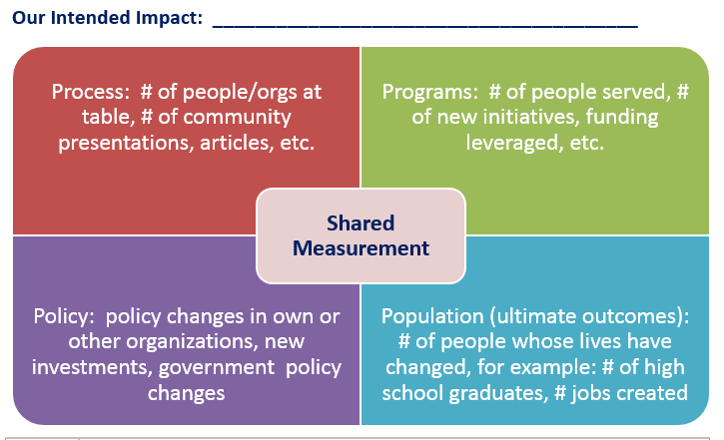

**EXERCISE DESCRIPTION:**

Otto Scharmer writes that to every farmer, a field is a living system with two aspects: **the visible,** which we see above the surface; and **the invisible**, which we find below the surface. No matter what actions the farmer takes, the quality of the harvest depends on aspects of the field that are invisible to the eye, such as the richness of the soil. Scharmer says we haven’t learned how to see below the surface, to decipher the subtle structures and principles that shape our outcomes, and to be as deliberate about enhancing the quality of the field as we are about producing results.

**Source:** ***Imagine Act Believe,* Annie E Casey Foundation**

Collaborative community change efforts are distinct because they involve many partners, engaged at different levels, working toward a shared outcome and measurable progress on a complex issue like poverty or infant mortality rates. Knowing that it can sometimes take more than a year to demonstrate impact on a population-level indicator, it is important for leaders to also consider how to effectively monitor, and demonstrate, their progress on the journey towards population-level change.

This **Shared Measurement Tool** should be used to generate an initial set of benchmarks or targets for the work of your collaborative. The **Outcomes Diary Tool** also included the Collective Impact Implementation Tool Box, offers a simple and effective means of monitoring and reporting on progress indicators.

**EXERCISE HOW-TO:**

1. Using your Common Agenda Tool as background, individually or in small groups, brainstorm the measures your collaborative would be demonstrating if you were making progress on your issue.
2. Use the attached grid to benchmarks for the various types of progress measures you might monitor to illustrate your progress towards the population level change you are striving for.

**EXERCISE DEBRIEF:**

* Generate a criteria for assessing potential benchmarks or targets. These might include: correlation to population level impact; ease of monitoring; etc.
* Dialogue and agree on a set of benchmarks to monitor
* Agree upon a process to collect, analyze and share results of these measures regularly

**Shared Measurement Mapping Worksheet**

The White House Roundtable on Community change evaluated 12 Collective Impact initiatives, and identified a set of questions which community partners need to consider.

* + Do we aim to effect ―needle-change (i.e., 10% or more) on a community-wide metric?
  + Do we believe that a long-term investment (i.e., three to five-plus years) by stakeholders is necessary to achieve success?
  + Do we believe that cross-sector engagement is essential for community-wide change?
  + Are we committed to using measurable data to set the agenda and improve over time?
  + Are we committed to having community members as partners and producers of impact?

**EXERCISE HOW-TO:**

1. Invite people to complete this questionnaire/poll individuals. This can even be done electronically.
2. Tabulate responses and share the results.
3. Use the responses as a starting point for more in-depth discussion and understanding.

**EXERCISE DEBRIEF:**

Typically, if the majority of people say yes to three or more of these five questions, it suggests that you have the necessary support to embark on a full Collective Impact approach.

**Shared Measurement Mapping Worksheet**

Our Intended Impact: \_\_\_\_\_\_\_\_\_\_\_\_\_\_\_\_\_\_\_\_\_\_\_\_\_\_\_\_\_\_\_\_\_\_\_\_\_\_\_\_\_\_\_\_\_\_\_\_\_\_\_\_\_

The Collective Impact Outcomes Diary

**EXERCISE DESCRIPTION:**

Community change efforts are akin to a snowstorm. There are many individual flakes of activity but they are difficult to distinguish once the snowstorm has finished. An Outcomes Diary can help you track both individual snowflakes and the cumulative results, and is best suited to a Collective Impact approach where many partners are moving several priorities forward all at the same time.

The outcomes you will be tracking are defined as *“the benefits or changes for individuals (or populations) after participating in your Collective Impact initiative’s activities”*. These can include: new knowledge, increased skills, changed attitudes, improved job status/income, improved health, etc. Be as specific as possible in the diary including dates, numbers impacted and results.

**EXERCISE HOW-TO:**

1. Work with key participants in your Collective Impact effort to identify the specific benefits or changes you want to monitor.
2. Educate all community partners in the outcomes you want to track and the importance of providing as much detail as possible re: numbers, dates, and/or results, and agree on a tracking schedule (weekly, monthly, etc.)
3. Establish a process or system to send out email requests to all partners for their diary entries as agreed, and consolidate results received into a spreadsheet.
4. Develop “Results Reports” that summarize the data from the Outcomes Diary and share it regularly with key partners and community members.

**EXERCISE DEBRIEF:**

Possible debrief questions include:

* Who will assume responsibility for issuing reminders for outcomes diary entries from all partners?
* Who should contribute to the diary?
* How frequently should Outcomes Diary Results Reports be developed and shared?

**The Collective Impact Outcomes Diary Worksheet**

**Documentation of Weekly Results**

| **Outcomes: The benefits or changes for individuals, families or populations after participating in the Collective Impact initiative’s activities. (For example: new knowledge, increased skills, changed attitudes, improved job status, etc. Please be as specific as possible re: numbers, dates, and results.** | | | |
| --- | --- | --- | --- |
| **Impact on Individuals, Families and Households** | | | |
| **Partner Name** | **Activity** | **Outcome** | **CI Initiative Involvement** |
| blank | blank | blank | blank |
| blank | blank | blank | blank |
| blank | blank | blank | blank |
| blank | blank | blank | blank |
| blank | blank | blank | blank |
| blank | blank | blank | blank |
| blank | blank | blank | blank |
| **How We Work Differently (Community Capacity)** | | | |
| **Partner Name** | **Activity** | **Outcome** | **CI Initiative Involvement** |
| blank | blank | blank | blank |
| blank | blank | blank | blank |
| blank | blank | blank | blank |
| blank | blank | blank | blank |
| blank | blank | blank | blank |
| blank | blank | blank | blank |
| blank | blank | blank | blank |
| **Policy and Systems Change** | | | |
| **Partner Name** | **Activity** | **Outcome** | **CI Initiative Involvement** |
| blank | blank | blank | blank |
| blank | blank | blank | blank |
| blank | blank | blank | blank |
| blank | blank | blank | blank |
| blank | blank | blank | blank |
| blank | blank | blank | blank |
| blank | blank | blank | blank |

The Most Significant Change Tool

**EXERCISE DESCRIPTION:**

The *Most Significant Change* technique is a form of participatory evaluation. It is participatory because many project stakeholders are involved both in deciding the sorts of change to be recorded, and in analyzing the data. It is a form of monitoring because it occurs throughout the program cycle and provides information to help people manage the program. It contributes to evaluation because it provides data on impact and outcomes that can be used to help assess the performance of the initiative as a whole. Essentially, the process involves the collection of significant change (SC) stories emanating from the field level, and the systematic selection of the most significant of these stories by panels of designated stakeholders or staff. The designated staff and stakeholders are initially involved by ‘searching’ for project impact. Once changes have been captured, various people sit down together, read the stories aloud and have regular and often in-depth discussion about the value of these reported changes. When the technique is implemented successfully, whole teams of people begin to focus their attention on program impact.

**EXERCISE HOW-TO:**

| **Steps** | **Questions** |
| --- | --- |
| 1. Raise interest amongst key stakeholders and get their commitment to participate. | blank |
| 1. Define the domains of change. | What has broadly changed in people’s lives? |
| 1. Determine the reporting period – over the past year, six months, 3 months etc. | blank |
| 1. Collective the significant change stories from participants. | During the last 6 months, in your opinion, what was the most significant change that took place for participants in this program? |
| 1. Select the most significant stories. Every time stories are selected, record criteria used to select them. | From among the stories selected, what do you think was the most significant change of all? |
| 1. Share back the results of the selection process. Include stakeholders to review the process, stories selected and assess the domains of stories. | From among the stories selected, what do you think was the most significant change of all? |
| 1. Verify the stories. | Who told the story? Who captured the results? When and where did the story take place? |
| 1. Quantify the results. | blank |
| 1. Conduct a secondary or meta-monitoring analysis. | blank |
| 1. Revise the system based upon lessons learned. | blank |

Source: [Most Significant Change Technique](http://mande.co.uk/docs/MSCGuide.pdf)

SECTION FOUR - Mutually Reinforcing Activities

**Overview**

Mutually reinforcing activities are the programs and services that are delivered which contribute to achieving the intended impact of your Collective Impact effort. This CI Condition includes: agreement on key outcomes; identifying opportunities for orchestration and specialization in the programs and services offered; and considering how complementary programs and activities might sometimes be “joined up” as strategies to achieve outcomes. By creating a shared understanding of programs and their design, it becomes possible to consider:

* Whether refinements in the design of existing programs and services could better support achievement of our intended impact
* Whether existing programs delivered by different providers can be better linked or aligned
* Whether there are gaps in the program and service delivery continuum that could be addressed to better achieve the intended impact of your CI effort.

**Tools for Mutually Reinforcing Activities**

1. **Designing Your Mutually Reinforcing Activities –** This exercise and worksheet is designed to guide a dialogue that supports your group to think together, and reach consensus, on the specific programs and activities that you will undertake to achieve your intended impact.
2. **Translating Strategy to Action Exercise** – This exercise is used to engage community partners in helping to co-create an inventory of program and services currently underway that are related to your Collective Impact effort.
3. **Existing Programs & Services Inventory Exercise** – This facilitation exercise provides a quick and easy way to engage community partners in helping to generate a current inventory of programs and services related to your issue.

**Resources for Going Deeper: Mutually Reinforcing Activities**

* **Tamarack Resource at a Glance: Frameworks for Change** – This 2-page resource summarizes the highlights of creating a Framework for Change.
* [**Theory of Change - An Evaluation Methodology to Accelerate Learning**](http://tamarackcci.ca/content/theory-change-evaluation-methodology-accelerate-learning) – In this audio seminar, Tom Kelly, VP for Knowledge, Evaluation and Learning with the Hawaii Community Foundation shares how a *Theory of Change* methodology can evaluate complex community change efforts and accelerate their impact.

Designing Your Mutually Reinforcing Activities

**EXERCISE DESCRIPTION:**

This tool enables groups to describe the activities they will undertake to ensure that they are achieving their intended impact. Ultimately, the group will be asked to draw a picture simply and easily conveys their work – its intended impact and priorities activities – in a single drawing. Groups then post their pictures and invite others to provide feedback on their thinking so that it can be further refined.

**EXERCISE HOW-TO:**

1. Small groups are formed – either all focused on the entire CI effort – or self-selected around key priority areas of work within the CI effort.
2. Small groups each work through the core questions in the worksheet and then draw a picture to illustrate their priority activities to achieve their intended impact. (30 minutes)
3. One person from the group stays with their picture to describe and animate it for others who come to review it. Visitors provide their feedback on the group’s picture – 1 comment per sticky note– and post their comments on the feedback matrix where appropriate. (15 minutes)
4. Group members return to their picture, review the feedback received, and revise. (15 minutes)
5. Each group identifies *3 Recommendations for Initial Actions* that they feel are needed to begin to put their proposed strategy into action. (15 minutes)
6. Each small group shares its *3 Recommendations for Initial Action* with the whole group. (15 minutes)

**EXERCISE DEBRIEF:**

Possible debrief questions:

* Are there any recommendations for initial action that we could not support?
* Consider using the **Stakeholder Engagement Wheel** to enable participants to self-identify their continued involvement in implementing Collective Impact activities.

**Designing Your Mutually Reinforcing Activities Worksheet**

Think about the emerging Common Agenda and consider the following elements:

Photo of elements to consider when thinking about a common agenda. 

What is our intended impact?
How will we know we are on track?
What are the specific activities? For how long? How often?
What staff, skills, systems, and tools do we need?
What external context creates the ideal program environment?

What are we trying to achieve? - Ultimate outcome, interim outcomes
How will we get there? - Activities, resources, context

**Summarize Your Emerging Consensus Below:**

| What are we trying to achieve? | **Ultimate Outcome**  *What is our intended impact*?  **Interim Outcomes**  *How will we know we are on track*? | blank |
| --- | --- | --- |
| How will we get there?  *Program, networking, advocacy, engagement etc.* | **Activities**  *What are the specific activities that we will undertake*? | blank |
| *Who leads each of these activities*? |  |
| *How long*? *How often?* |  |
| *For Whom*? |  |

**Draw a road map of how you will achieve your intended impact. Take into consideration your Common Agenda & Shared Measurements.**

**Mutually Reinforcing Activities - Feedback Matrix**

4 sections: What I like about this, What I would improve is, Questions I still have, and New ideas this gives me


Translating Strategy to Action Exercise

**EXERCISE DESCRIPTION:**

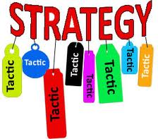Developing a Collective Impact strategy requires that the group’s mutually reinforcing activities are fitted together in support of a larger strategy. The goals and outcomes of these activities should be linked to the shared measurement and intended impact of your Collective Impact effort. It is also important that deliberate attention be given to identifying specific system strategies that are focused beyond programs to affect systems change. In identifying strategies, participants should consider the following levers for change:

* Policy
* Practice
* Funding and resources
* Community awareness and voice
* Access to and use of data

**EXERCISE HOW-TO:**

Form small groups to engage in dialogue to:

* Identify 3-5 high leverage strategies for addressing your Collective Impact effort.
* Consider what mutually reinforcing activities are needed within each strategy.
* Articulate how these activities are expected to create community-level change.

**EXERCISE DEBRIEF:**

Possible debrief questions as small groups present their ideas to the whole group:

* Is there anything in this presentation that you need clarified?
* Is there anything in this presentation that you could not support being implemented?

Existing Programs & Services Inventory Exercise

**EXERCISE DESCRIPTION:**

This exercise provides a quick and easy way to engage community partners in helping to generate a current inventory of programs and services related to your issue.

**EXERCISE HOW-TO:**

1. Identify key priority areas within your Collective Impact effort and post them on a blank wall.
2. Invite participants to think about the program or activities that they and/or their organization delivering – or those they are aware of in the community – that contribute to your Collective Impact effort. Write the name of each program or activity on a sticky note. Each sticky note should have:
   1. The name of the activity or program
   2. Their own name and email address (in case people want to know more) (15 minutes)
3. Post the sticky notes under the appropriate heading/priority area on the wall. Effort should be made to cluster duplicate and/or like sticky notes together (15 minutes)
4. Compile and offer to share this inventory with all participants.

**EXERCISE DEBRIEF:**

Invite participants to view what’s been posted on the wall:

* Look at all the work we are currently doing. What might be possible if we could better coordinate and align this work?

SECTION FIVE - Continuous Communications

**Overview**

The fourth condition of Collective Impact is continuous communication. It includes the need to establish both formal and informal mechanisms for keeping people informed about the progress and key milestones of a Collective Impact effort.

Beyond defining the appropriate communication pathways and vehicles, this condition also encompasses the need to ensure that the work of the Collective Impact Initiative is communicated openly to a diversity of audiences, and therefore, utilizes a range of communication styles.

A comprehensive communications strategy for a Collective Impact effort encompasses:

* Establishing structures that facilitate effective communication between and among CI Initiative partners – including practices that ensure that difficult issues within the initiative are surfaced, discussed and addressed
* Considering what the Collective Impact initiative’s partners need to facilitate their ability to communicate about its work within their own organizations and networks; and,
* Strategies to facilitate keeping the public informed and engaged in the Collective Impact initiative.

**Continuous Communications Tools**

1. **The 4 “M”s Effective Communications Tool** – This tool helps to clarify your communications strategy for maximum effectiveness.

**Resources for Going Deeper: Continuous Communication**

* [**Communication and Movements for Change**](http://tamarackcci.ca/content/communication-and-movements-change-0) **–** This audio seminar features Shauna Sylvester, the co-founder of IMPACS (The Institute for Media, Policy and Civil Society), explores the impact of marketing and communication in the development of a movement for change and its role in supporting and growing that movement.

The 4 “M”s Effective Communications Tool

**EXERCISE DESCRIPTION:**

This tool is designed to help you to map out the most effective approach to continuously communicate about how your Collective Impact initiative is evolving; the progress you are making on your shared measures; and also how best to share your learning with one another.

The 4 “Ms” of Effective Communications are:

1. **Member** – Who is the target of this message?
2. **Method** – What communications tool(s) will work best?
3. **Moment** – When is the best time to convey this message?
4. **Message** – What action(s) do we want this person to do?

**EXERCISE HOW-TO:**

1. Individually, or with your Collective Impact partners, work through the 4 Ms worksheet.

**EXERCISE DEBRIEF:**

Possible debrief questions include:

* How will we know that our communications are having their intended impact?
* Are there specific “calls to action” that we want to include within our communications?

**The 4 “M”s Effective Communications Worksheet**

| **Member** | **Method** | **Moment** | **Message** |
| --- | --- | --- | --- |
| **Who is the target for this message?** | **What communications tool will work best?** | **When is the best time to convey this message?** | **What action(s) do we want this person to take?** |
| blank | blank | blank | blank |
| blank  blank | blank | blank | blank |
| blank | blank | blank | blank |
| blank | blank | blank | blank |
| blank | blank | blank | blank |
| blank | blank | blank | blank |
| blank | blank | blank | blank |
| blank | blank | blank | blank |
| blank | blank | blank | blank |
| blank | blank | blank | blank |
| blank | blank | blank | blank |
| blank | blank | blank | blank |

SECTION SIX - Backbone Infrastructure

**Overview**

The backbone infrastructure of a Collective Impact effort is focused on six core roles. These are: guide vision and strategy; support aligned activities; established shared measurements; build public will; advance policy; and, mobilize funding. An in-depth study of successful backbone organizations by FSG, revealed that: their value is unmistakeable; backbones share strengths in guiding vision and strategy and supporting aligned activities; backbone organizations shift focus over time, and need ongoing assistance with data, external communications, building public will, and advancing policy.

Characteristics of effective backbone leaders include being: a visionary, results-oriented, a collaborative relationship-builder, a charismatic and an influential communicator, politic and humble, and *“someone who has a big picture perspective– who understands how the pieces fit together, is sensitive to the dynamics, and is energetic and passionate.”*

There are several misperceptions about the backbone. Common ones include: that the backbone sets the agenda for the group; drives the solutions; receives all the funding; that the role of backbone can be self-appointed rather than selected by the community; and, that its role isn’t fundamentally different from “business as usual” in terms of staffing, time, and resources.

Often, but not always, the backbone serves as the fiscal sponsor. Establishing an effective collaborative governance structure to support the work of the Collective Impact initiative is another important aspect of the work of the backbone organization.

**Backbone Infrastructure Tools**

1. **Collaborative Governance Framework** – This framework outlines key principles for establishing an effective collaborative governance structure for your Collective Impact effort.
2. **Collective Impact Initiative Budgeting Tool** – This tool will guide the development of a budget for your Collective Impact effort.
3. **Planning Your Backbone Support Tool** – This tool allows leaders of a Collective Impact effort to assess, and plan for, the necessary human resources to fulfill the six core roles of the backbone.

**Resources for Going Deeper: Backbone Infrastructure**

* [**Understanding the Value of Backbone Organizations in Collective Impact**](file:///C:\Users\Sylvia\Dropbox\Tamarack%202015%20Work\Custom%20Consulting\Healthy%20Start%20-%20VA\CI%20Capacity-Building%20Contract\CI%20Implementation%20Tool-Kit\•%09http:\www.ssireview.org\blog\entry\understanding_the_value_of_backbone_organizations_in_collective_impact_1), *Stanford Social Innovation Review, 2012.* This four-part series has additional information about how backbone organizations support the work of collective impact initiatives.
* [**The Centre for Social Innovation’s Constellation Model of Collaborative Governance**](http://socialinnovation.ca/constellationmodel) – This article outlines the primary features of the collaborative governance model and highlights examples.
* [**Collective Impact Backbones: What We Are Learning**](http://tamarackcci.ca/blogs/kirsti-battista/collective-impact-backbones-what-we-are-learning) – In this webinar, John Kania and Liz Weaver engage in a lively discussion about how the role and impact of backbones and how these concepts have evolved over the past five years.
* **Sample Collaborative Governance Agreements** – There are several examples of organizations that have adapted the principles of the *Constellation Model* to create their agreement document. Examples include:
  + [**Canadian Partnership for Children’s Health and the Environment Terms of Reference**](http://www.healthyenvironmentforkids.ca/)
  + [**Ontario Non-Profit Network Governance Document**](http://socialinnovation.ca/sites/default/files/ONN%20Governance%20Nov%202009.pdf)
  + [**Ontario Literacy Coalition**](http://socialinnovation.ca/sites/default/files/Ontario%20Literacy%20Coalition%20version%20of%20Constellation%20model_0.pdf)
  + [**StepUp B.C.**](http://socialinnovation.ca/sites/default/files/Constellation-prototype.pdf)
* [**Collective Impact Forum’s Backbone Tool-Kit**](http://www.collectiveimpactforum.org/resources/tools-backbones) – This tool-kit includes: a list of sample backbone activities; a Working Group Meeting Planning & Execution Checklist; a Sample RFP for a Backbone Organization; and, Sample Backbone Position Descriptions

Collaborative Governance Framework

**Collaborative Governance Principles**

* **Transparency and Accountability:** Decisions take place in the public eye.
* **Equity and Inclusiveness**: All interests who are needed and willing contribute to solutions.
* **Effectiveness and Efficiency**: Solutions are tested to make sure they make practical sense.
* **Responsiveness:** Public concerns are authentically addressed.
* **Forum Neutrality:** Different perspectives are welcome; the process itself has no bias.
* **Consensus-Based:** Decisions are made through consensus rather than majority rule.

**EXERCISE DESCRIPTION:**

The core elements of collaborative structure and governance include:

* Working through a host/convener
* Managing overlapping roles in the governance structure
* A leadership group
* A backbone organization with staff
* A fiscal/legal agent
* Executive or Coordinating Committee
* Working Groups and/or Action Teams

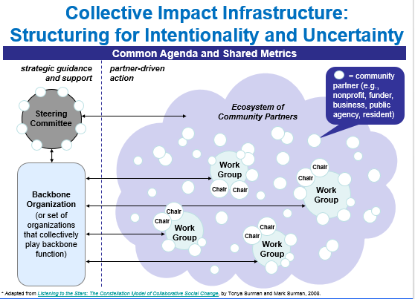There is no one right answer for how best to establish a collaborative governance model. Instead, models are shaped by the following factors: local context; member attributes; magnitude and pace of change desired; the style and spirit of the leadership; the group’s framework for change; the preferences of the convener or fiscal sponsor; and the flexibility and adaptability your initiative requires. A good design for collaborative governance is one in which:

* The group is making satisfactory progress;
* The effort and conflict required to make progress is reasonable;
* Members are achieving some personal or organizational objectives;
* Everyone involved is learning much more about the complex issue; and,
* The overall process is self-refueling, leading to greater ambition and capacity for the initiative.

**EXERCISE HOW-TO:**

1. Use the information above and the Collaborative Governance Framework Worksheet to guide a dialogue among your Collective Impact initiative’s leadership.
2. Assess the strengths and gaps within the initiative’s governance structure and develop an action plan.

**EXERCISE DEBRIEF:**

* What actions are needed based upon our reflections?
* Who will do what and by when?

**Collaborative Governance Framework Worksheet**

| **Role** | **Who Can Fill  this Role?** | **Current Strengths/ Weaknesses** | **Next Steps** |
| --- | --- | --- | --- |
| **Host & Convener** | blank | blank | blank |
| **Managing Overlapping Governance Roles** | blank | blank | blank |
| **Leadership Group** | blank | blank | blank |
| **Backbone Infrastructure with Staff** | blank | blank | blank |
| **Fiscal Agent** | blank | blank | blank |
| **Executive Committee** | blank | blank | blank |
| **Working Groups or Action Teams** | blank | blank | blank |
| **Citizen Engagement & Participation** | blank | blank | blank |

Collective Impact Initiative Budgeting Tool

**EXERCISE DESCRIPTION:**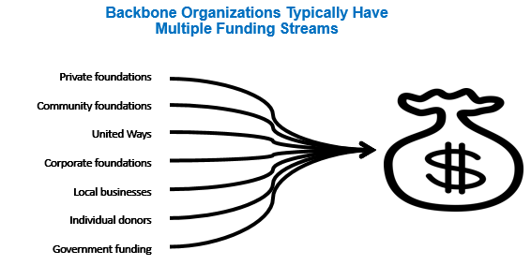

Collective Impact initiatives benefit from generating their budget by engaging multiple funding streams.

There is a considerable range in their operating budgets as well, and the budget requirements of Collective Impact effort tends to evolve over time as the work of the initiative expands and grows.

The two visuals below provide examples of the range in budgets of Collective Impact efforts and how they evolve over time. 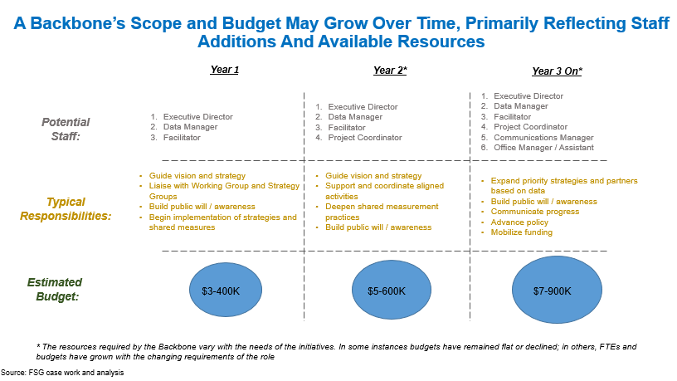

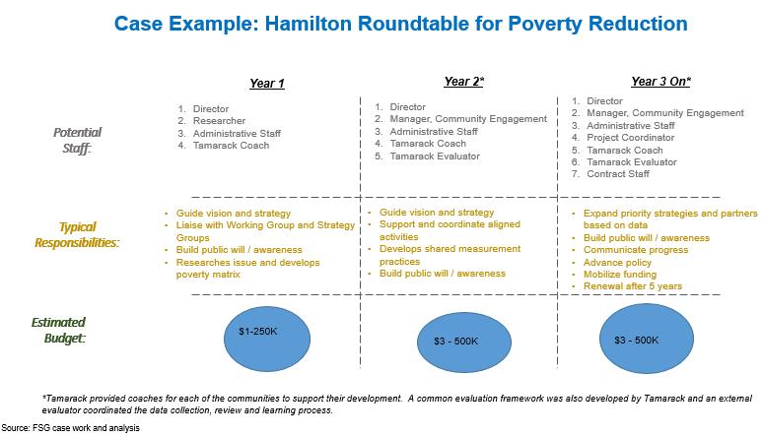

**EXERCISE HOW-TO:**

1. Individually, or as a group, complete the Collective Impact Initiative Budget Worksheet.

**EXERCISE DEBRIEF:**

* How can we best incorporate the in-kind resources and/or partner contributions to reflect the true costs of, and contributions secured for, our Collective Impact effort?

**Collective Impact Initiative Budget Worksheet**

|  |  |  |  |  |
| --- | --- | --- | --- | --- |
| **Expense Category** | **Budget Range ($)** | | **CI Initiative**  **Budget** | **Description** |
| **Low** | **High** |
| **Salaries** | 80,000 | 155,000 |  | 1 FTE Executive Director |
|  | 55,000 | 100,000 |  | 1 FTE Facilitator/Coordinator |
|  | 65,000 | 100,000 |  | 1 FTE Data/Operations Manager |
|  | 25,000 | 65,000 |  | 0.5-1 FTE Admin. Support |
| **Benefits** | 45,000 | 84,000 |  | At 20% of salaries |
| **Professional Fees** | 90,000 | 105,000 |  | Consultants, R&E, Recruiting, Data Collection |
| **Travel and Meetings** | 7,000 | 30,000 |  | Workshops, events, retreat |
| **Community Engagement** | 0 | 35,000 |  | Space rental, youth stipends |
| **Communications** | 36,500 | 90,000 |  | Reports, materials design, paid media |
| **Technology** | 0 | 4,900 |  | In-kind hardware, software, IT |
| **Office** | 0 | 74,000 |  | In-kind/paid rent, utilities, supplies |
| **Other** | 0 | 6,500 |  | Staff training, miscellaneous |
| Total Expenses | **403,500** | **849,400** |  | Covered by grants and fees |

Planning Your Backbone Support

**EXERCISE DESCRIPTION:**

This tool is designed to help you to assess and further develop your Collective Impact initiative’s Backbone Support Infrastructure. There are six core roles and responsibilities of backbone organizations in Collective Impact initiatives. The six roles are:

1. **Guide Vision and Strategy** – This includes building a common understanding of the issue and; providing strategic guidance to develop a common agenda.
2. **Support Aligned Activities** – This involves ensuring, and monitoring, the mutually reinforcing activities that are taking place.
3. **Establish Shared Measurement Practices** – This involves establishing agreed upon metrics and monitoring activities.
4. **Build Public Will** – This work involves continuing to build consensus and commitment around your issue.
5. **Advance Policy** – This is about ensuring an aligned policy agenda is part of the Collective Impact effort.
6. **Mobilize Funding** – This work is focused on aligning public and private funding in support of the Collective Impact effort’s goals.

**EXERCISE HOW-TO:**

1. Engage the leadership of your Collective Impact effort in completing the Planning Your Backbone Worksheet together.
2. Consider convening influential community champions to provide input and offer recommendations for key individuals and/or secondments.
3. The leadership group should consider opportunities to share, or build redundancy, into key roles and functions. In more mature Collective Impact efforts, consider succession planning needs.

**EXERCISE DEBRIEF:**

* What are the current strengths and weaknesses within our current backbone infrastructure?
* Have we embedded adequate redundancy into essential backbone roles?
* How do we plan for succession?

**Planning Your Backbone Support Worksheet**

Spend some time thinking through who will fill, or share, these backbone roles. Identify who can take these on, your overall strengths and weaknesses, and your next steps. Be sure to think long term, not just for the brief timeframe of a single year.

| **Role** | **Who Can Fill  this Role?** | **Current Strengths/ Weaknesses** | **Next Steps** |
| --- | --- | --- | --- |
| **Guide Vision  and Strategy** | blank | blank | blank |
| **Support Aligned Activities** | blank | blank | blank |
| **Establish Shared Measurement Practices** | blank | blank | blank |
| **Build Public Will** | blank | blank | blank |
| **Advance Policy** | blank | blank | blank |
| **Mobilize Funding** | blank | blank | blank |

SECTION SEVEN - Bringing it All Together

**Overview**

This section provides a framework for Collective Impact Implementation for Healthy Start grantees. The work generated in the worksheets included in this tool box will help to synthesize a clear CI Implementation Action Plan for the coming year.

**Tools for Bringing It All Together**

1. Collective Impact Year I Action Plan Framework—This framework helps you to identify actions, information needs and a timeline needed to achieve the intended impacts of your Collective Impact effort, in accordance with your theory of change.
2. Year I Collective Impact Action Plan Summary—This worksheet summarizes your Collective Impact initiative’s planned actions for the coming year across the five CI conditions.
3. **Healthy Start Collective Impact PLN: CAN Action Plan Template**—This template is designed to help Healthy Start Community Action Networks (CAN) to reflect on progress made in advancing their Collective Impact initiative, and consider what is needed to move forward.

**Resources for Going Deeper: Bringing It All Together**

***Collective Impact Case Studies***

* [**FSG Collective Impact Case Studies**](http://tamarackcci.ca/blogs/community-animator/collective-impact-resources-8-case-studies-successful-initiatives) – Eight case studies illustrate Collective Impact initiatives across a range of issues areas. Each case study describes how the initiative began, how the five conditions of Collective Impact have taken shape, results to date, and lessons learned.
* [**Vibrant Communities Canada CI Case Study**](http://www.fsg.org/tabid/191/ArticleId/979/Default.aspx?srpush=true)– This FSG case study profiles the work of Tamarack’s Vibrant Communities Canada National Poverty Reduction Initiative.
* [**Halton Our Kids Network**](http://www.ourkidsnetwork.ca/) – This regional Collective Impact effort is a mature collaboration focused on ensuring that all children (aged 0-18) thrive.
* [**Headwaters Communities in Action**](http://www.headwaterscommunities.org) – This rural Collective Impact effort was launched from a community conversation facilitated by Tamarack in 2004 and has since grown to champion community well-being; active transportation and trails; non-profit capacity-building and regional food systems using a multi-sector, collaborative approach that spans sectors and political boundaries.

***Videos on Collective Impact***

* [**What is Collective Impact**](https://www.youtube.com/watch?v=HNOnrrIYvdo)– This FSG video provides a brief explanation of Collective Impact in just under two minutes.
* [**Tackling Complex Social Problems Through Collective Impact**](https://www.youtube.com/watch?v=pzmMk63ihNM) – What is Collective Impact? How is it different from other forms of collaboration? We know that these questions aren’t always easy to answer, even for Collective Impact practitioners.
* [**Collective Impact Practitioners Insights**](http://www.youtube.com/watch?v=FrD5SopqWdY)Paul Born and Liz Weaver, Tamarack – An Institute for Community Engagement.
* [**Community Collaboratives Toolbox**](http://www.serve.gov/sites/default/files/ctools/CommunityCollaborativeToolkit_all%20_materials_1.pdf), *White House Council for Community Solutions, 2013.* – This comprehensive toolkit provides communities with an excellent framework to start building solutions to address youth concerns, especially with developing comprehensive solutions for *Opportunity Youth.*

***Websites and Tools for Collective Impact Practitioners***

* [**Tamarack’s Communities Collaborating Institute Online**](http://tamarackcci.ca/learn)– This online forum offers resources and podcasts, and the opportunity to connect with other Collective Impact practitioners.
* [**FSG's Collective Impact Forum**](http://collectiveimpactforum.org/) **–** This practitioner community offers access to resources, examples from the field, and a robust online cohort of Collective Impact professionals.
* [**FSG’s Collective Impact Blog**](http://www.fsg.org/KnowledgeExchange/Blogs/CollectiveImpact.aspx)– This frequently updated blog focuses on many aspects of Collective Impact, including new research and articles.

**Collective Impact Year I Action Plan Framework**

**Healthy Start Grantee: \_\_\_\_\_\_\_\_\_\_\_\_\_\_\_\_\_\_\_\_\_\_\_\_\_\_\_\_\_\_\_\_\_\_\_\_\_\_\_\_**

| **A) Population Level Outcomes** | | |
| --- | --- | --- |
| **Our Desired Impact:**  **Who are we trying to impact? What impact are we trying to create for them? When will we do this? How much impact will we have?** | | |
| **Our Intended Impact Statement:**  **Our Draft Intended Impact Statement Is:** | | |
| **B) Our Theory of Change**  **What activities would you like to explore this year related to your theory of change?** | | | |
| * **What activities are required this year to achieve our desired impact?** * **Who will be responsible for implementing these activities?** * **When could the activities be done?** | | | |
| **Activity** | **Who Will Lead?** | **By When?** | |
| blank | blank | blank | |
| blank | blank | blank | |
| blank | blank | blank | |
| blank | blank | blank | |
| blank | blank | blank | |
| blank | blank | blank | |
| blank | blank | blank | |
| blank | blank | blank | |
| blank | blank | blank | |
| blank | blank | blank | |
| blank | blank | blank | |
| blank | blank | blank | |
| blank | blank | blank | |
| blank | blank | blank | |
| blank | blank | blank | |
| blank | blank | blank | |
| blank | blank | blank | |
| blank | blank | blank | |

| **B) Our Theory of Change – A Visual** |
| --- |
| **Can you create a visual that describes your Theory of Change on a single page? Draw it here:** |

| **C) Additional Information Needed for Our Collective Impact Strategy** |
| --- |
| **Additional Information Required:**  **What additional information is still needed to develop and/or refine our Collective Impact strategy?** |
| **How Will We Learn What We Need?**  **What is our plan to obtain, and make sense of, the additional information we need to refine our strategy?** |

| **C) Our Information Gathering Action Plan**  **How will we collect the information we need to answer our key outstanding questions?** | | |
| --- | --- | --- |
| * **What are the priority information gathering activities we need to focus on over the next 3-6 months as we finalize our plan? (One priority will be stakeholder engagement as outlined in #5)** * **Who will be responsible for undertaking each information gathering activity?** | | |
| **Activity** | **Who Will Lead?** | **By When?** |
| Blank | Blank | Blank |
| Blank | Blank | Blank |
| Blank | Blank | Blank |
| Blank | Blank | Blank |
| Blank | blank | Blank |
| Blank | Blank | blank |
| Blank | Blank | blank |
| Blank | Blank | blank |
| Blank | Blank | blank |
| Blank | Blank | blank |
| Blank | Blank | blank |
| Blank | Blank | blank |
| Blank | Blank | blank |
| Blank | Blank | blank |
| Blank | Blank | blank |
| blank | blank | blank |

| **D) Stakeholder Engagement**  **How will we collect the information we need and answer our key outstanding questions?** | | | |
| --- | --- | --- | --- |
| * **Based on the major activities to be accomplished, who do we need to engage first?** * **Why are we reaching out to this person/organization? What do we want them to do? (check your logic based on your Theory of Change)** * **Who on our team is the best person to reach out to this potential partner?** | | | |
| **Organization or Individual** | **Rationale for Engagement?** | **Key Contact** | **Who Will Lead This?** |
| Blank | Blank | Blank | Blank |
| Blank | Blank | Blank | Blank |
| Blank | Blank | Blank | Blank |
| Blank | Blank | Blank | blank |
| Blank | Blank | Blank | blank |
| Blank | Blank | Blank | blank |
| Blank | Blank | Blank | blank |
| Blank | Blank | Blank | blank |
| Blank | Blank | Blank | blank |
| Blank | Blank | Blank | blank |
| Blank | Blank | Blank | blank |
| Blank | blank | blank | blank |
| Blank | Blank | blank | blank |
| Blank | Blank | Blank | blank |
| Blank | Blank | Blank | blank |
| blank | Blank | blank | blank |

Collective Impact Year I Action Plan Summary

**Our Intended Impact: \_\_\_\_\_\_\_\_\_\_\_\_\_\_\_\_\_\_\_\_\_\_\_\_\_\_\_\_\_\_**

| **Collective Impact** | **Gaps or Priorities** | **Actions**  **Months 1-4** | **Actions**  **Month 5-8** | **Actions**  **Month 9-12** |
| --- | --- | --- | --- | --- |
| **Common Agenda**/  Clarify Theory of Change and generate stakeholder buy-in | blank | blank | blank | blank |
| Refine and advance a **Shared Measurement** strategy & system | blank | blank | blank | blank |
| Build a system of **Mutually Reinforcing**  **Activities** to achieve your intended impact | blank | blank | blank | blank |
| Develop a **Resources** plan to move your Collective Impact work forward | blank | blank | blank | blank |

| **Year I CI Action Plan Reflection Questions:** |
| --- |
| **Our Outstanding Questions:**  **What are the top three questions that we need to answer, or refine (based on our findings today) to build our Collective Impact strategy?** |
| **Our Assumptions:**  **What assumptions are we making that we will be testing as our Collective Impact Strategy is refined?** |

Collective_Impact_Logos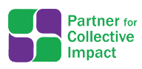Healthy Start Collective Impact PLN: CAN Action Plan Template

**(Optional Template/Tool)**

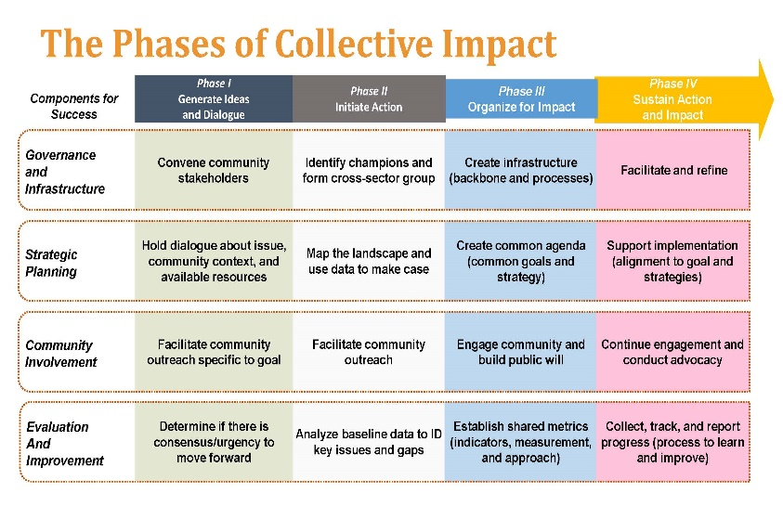The purpose of this template is to help the CAN reflect on progress made in advancing their Collective Impact initiative, and to consider what is needed to support moving to the next stage of clarity and action.

**EXERCISE DESCRIPTION:**

Over the past several months, the Healthy Start Collective Impact – Peer Learning Networks (CI-PLNs) have discussed the pre-conditions (influential champion, financial resources, and urgency) and conditions of Collective Impact (common agenda, shared measurement, mutually reinforcing activities, continuous communication, and backbone support). Collective Impact is not a linear process, meaning, elements of the pre-conditions and/or conditions should be occurring simultaneously throughout each phase of the initiative. FSG’s *Phases of Collective Impact* document demonstrates this well. In designing this Action Plan template, which is an optional resource for HS grantees, the Healthy Start CI-PLN co-facilitation team decided to use FSG’s phases document as a frame. With the help of the Tamarack Institute additional details, descriptions, and examples have been added to make it a more meaningful planning tool.

EXERCISE HOW-TO:

This exercise is intended to be completed with your CAN. Depending on the stage of development and desire of the membership, initial drafts may be completed at the work group level, Steering Committee, or even with the full CAN membership. If you are at the initial stages of design and engagement, then it may be most appropriate to start this planning process with the Healthy Start team and key stakeholders (as available).

For each component of success, read through the descriptions, focus areas, and key elements of the four phases. Consider which description most closely matches the phase your CAN/CI initiative is currently experiencing. Using the corresponding section of the template describe why you selected a particular phase. It may be that your CAN/CI Initiative is in more than one phase. Explain how your CAN/CI Initiative fits or does not quite yet fit the phase as described. Use the Phases of CI information to developed a 12 month goal, corresponding activities and persons responsible, timeframe, and ideas for successfully completing each activity (e.g. identify tool). Once all four components of success Action Plans are drafted, then the CAN/team can ensure alignment across all.

SUPPLEMENTAL TOOL:

The supplemental tool, Assessing Our Progress, may help you and your CAN/team dig deeper when considering your phase, priorities, and next steps. You can use this tool to assess the progress of your CAN as a whole or break it down by component of success. To complete the tool, meet with CAN/team to discuss and answer each question. Use information to help to help identify goals and activities for upcoming year.

| **The Phases of Collective Impact** | | | | | | |
| --- | --- | --- | --- | --- | --- | --- |
| **Over-arching Actions** | **Components of Success** | **Phase I**  ***Generate Ideas and Host Dialogues*** | **Phase II**  ***Initiate Action*** | **Phase III**  ***Organize for Impact*** | | **Phase IV**  ***Sustain Action and Impact*** |
| Pre start-up  *Focus: Engagement and Exploration* | Start up  *Focus: From Idea to Formation* | Growth  *Focus: Experimentation and Growth* | | Maturity  *Focus: Sustain and Renew* |
| EARLY YEARS  Key Question: *What needs to happen?* | | MIDDLE YEARS  Key Question: *How well is it working?* | | LATER YEARS  Key Question*: What difference are we making?* |
| **KEY ELEMENTS** | | | | |
| **Design, Implement and Lead your CI Initiative** | **Governance and Infrastructure**  How decisions are made and responsibilities shared | Convene Community Stakeholders | Identify champions and form cross-sector group | | Create infrastructure (backbone and processes) | Facilitate, refine and renew |
| **Strategic Planning**  What are we trying to do and how: Our  Theory of Change | Hold dialogue about issue, community context and available resources | Map the landscape and use data to make the case | | Create common agenda (shared goals and strategy) | Support implementation (alignment to goal and strategies) |
| **Understand Context** | **Community Involvement**  Who is involved? Who else’s eyes need to be on this issue? | Facilitate community outreach specific to goal | Facilitate community outreach | | Engage community and build public will | Continue engagement and conduct advocacy |
| **Assess Progress, Outcomes, Impact and Learning** | **Evaluation and Improvement**  What are we learning and how are we changing culture, norms and systems? | Determine if there is consensus and urgency to move forward | Analyze baseline data to ID key issues and gaps | | Establish shared metrics (indicators, measurement and approach) | Collect, track and report progress (process to learn and improve) |

**CAN/CI Action Plan for: Governance and Infrastructure**

| **Over-arching Actions** | **Components of Success** | **Phase I**  ***Generate Ideas and Host Dialogues*** | **Phase II**  ***Initiate Action*** | | | **Phase III**  ***Organize for Impact*** | | | **Phase IV**  ***Sustain Action and Impact*** | | |
| --- | --- | --- | --- | --- | --- | --- | --- | --- | --- | --- | --- |
| Pre start-up  *Focus: Engagement and Exploration* | Start up  *Focus: From Idea to Formation* | | | Growth  *Focus: Experimentation and Growth* | | | Maturity  *Focus: Sustain and Renew* | | |
| EARLY YEARS  Key Question: *What needs to happen?* | | | | MIDDLE YEARS  Key Question: *How well is it working?* | | | LATER YEARS  Key Question*: What difference are we making?* | | |
| **KEY ELEMENTS (including examples of activities)** | | | | | | | | | |
| Design, Implement and Lead your CI Initiative | **Governance and Infrastructure**  How decisions are made and responsibilities shared | **Convene community stakeholders**   1. Identify and foster relationships with stakeholders 2. Gain commitment from leaders of multiple sectors to work on shared issue 3. Address the five collective impact framing questions | | **Identify champions and form cross-sector group**   1. Train backbone staff to be neutral and inclusive 2. Establish Steering or Leadership Committee made up diverse voices and different sectors 3. Establish collaborative governance agreement and develop MOUs | | **Create infrastructure (backbone and processes)**   1. Establish process for managing, convening, and supporting needs of Steering Committee and Work Group members 2. Obtain new/additional resources to support CI Initiative | | **Facilitate, refine and renew**   1. Revisit processes to determine if they are effectively supporting the initiative’s infrastructure needs 2. Develop a policy agenda and nurture partner capacity to assist with agenda 3. Plan for succession | | |
| **CAN/CI Initiative’s current phase:** | | **Why did you select this phase?** | | | | | | | | |
| **CAN/CI Initiative’s 12 Month Goal for this component:** | | blank | | | | | | | | |
| **Activities to Reach 12 Month Goal:** | | | | | **Who’s Responsible?** | | **By When?** | | | **How? (e.g. Potential CI Tools)** |
| blank | | | | | blank | | blank | | | blank |
| blank | | | | | blank | | blank | | | blank |
| blank | | | | | blank | | blank | | | blank |

**CAN/CI Action Plan for: Strategic Planning**

| **Over-arching Actions** | **Components of Success** | **Phase I**  ***Generate Ideas and Host Dialogues*** | **Phase II**  ***Initiate Action*** | | | **Phase III**  ***Organize for Impact*** | | | **Phase IV**  ***Sustain Action and Impact*** | | |
| --- | --- | --- | --- | --- | --- | --- | --- | --- | --- | --- | --- |
| Pre start-up  *Focus: Engagement and Exploration* | Start up  *Focus: From Idea to Formation* | | | Growth  *Focus: Experimentation and Growth* | | | Maturity  *Focus: Sustain and Renew* | | |
| EARLY YEARS  Key Question: *What needs to happen?* | | | | MIDDLE YEARS  Key Question: *How well is it working?* | | | LATER YEARS  Key Question*: What difference are we making?* | | |
| **KEY ELEMENTS (including examples of activities)** | | | | | | | | | |
| Design, Implement and Lead your CI Initiative | **Strategic Planning**  What are we trying to do and how: Our  Theory of Change | **Hold dialogue about issue, community context and available resources**   1. Generate a current inventory of programs and services related to issue 2. Research and document influential factors related to the issue | | **Map the landscape and use data to make the case**   1. Identify clear goals and priorities that will help inform common agenda 2. Identify community needs and assets 3. Invite key stakeholders, partners, community members to share data | | **Create common agenda (shared goals and strategy)**   1. Reach consensus on ultimate goal and commit to shared vision 2. Establish a culture of experimentation and adaptation 3. Determine CI Initiative’s community aspiration | | **Support implementation (alignment to goal and strategies)**   1. Assist partner organizations with adopting elements of the CI Initiative or policy agenda 2. Identify and develop strategies to address gaps and/or better align services | | |
| **CAN/CI Initiative’s current phase:** | | **Why did you select this phase?** | | | | | | | | |
| **CAN/CI Initiative’s 12 Month Goal for this component:** | |  | | | | | | | | |
| **Activities to Reach 12 Month Goal:** | | | | | **Who’s Responsible?** | | **By When?** | | | **How? (e.g. Potential CI Tools)** |
| blank | | | | | blank | | blank | | | blank |
| blank | | | | | blank | | blank | | | blank |
| blank | | | | | blank | | blank | | | blank |

**CAN/CI Action Plan for: Community Involvement**

| **Over-arching Actions** | **Components of Success** | **Phase I**  ***Generate Ideas and Host Dialogues*** | **Phase II**  ***Initiate Action*** | | | **Phase III**  ***Organize for Impact*** | | | **Phase IV**  ***Sustain Action and Impact*** | | |
| --- | --- | --- | --- | --- | --- | --- | --- | --- | --- | --- | --- |
| Pre start-up  *Focus: Engagement and Exploration* | Start up  *Focus: From Idea to Formation* | | | Growth  *Focus: Experimentation and Growth* | | | Maturity  *Focus: Sustain and Renew* | | |
| EARLY YEARS  Key Question: *What needs to happen?* | | | | MIDDLE YEARS  Key Question: *How well is it working?* | | | LATER YEARS  Key Question*: What difference are we making?* | | |
| **KEY ELEMENTS (including examples of activities)** | | | | | | | | | |
| Design, Implement and Lead your CI Initiative | **Community Involvement**  Who is involved? Who else’s eyes need to be on this issue? | **Facilitate community outreach specific to goal**   1. Inform community and partners about the CAN 2. Convene conservations with diverse voices from community and partners 3. Establish structure and process for keeping partners and community well informed about CI efforts | | **Facilitate community outreach**   1. Engage members with “lived experience” to help shape the common agenda 2. Define geographical boundaries and population focus areas 3. Assist partners and community with understanding the importance of and their role in shared measures | | **Engage community and build public will**   1. Ensure shared ownership of common agenda 2. Partners feel a collective accountability for results 3. Ensure workgroup members have clear approaches/goals specific to their workgroup contributions | | **Continue engagement and conduct advocacy**   1. Encourage and assist partners with using shared data to guide decision making in their own organization 2. Partners and community members determine best approach for disseminating results and learning | | |
| **CAN/CI Initiative’s current phase:** | | **Why did you select this phase?** | | | | | | | | |
| **CAN/CI Initiative’s 12 Month Goal for this component:** | | blank | | | | | | | | |
| **Activities to Reach 12 Month Goal:** | | | | | **Who’s Responsible?** | | **By When?** | | | **How? (e.g. Potential CI Tools)** |
| blank | | | | | blank | | blank | | | blank |
| blank | | | | | blank | | blank | | | blank |

**CAN/CI Action Plan for: Evaluation and Improvement**

| **Over-arching Actions** | **Components of Success** | **Phase I**  ***Generate Ideas and Host Dialogues*** | **Phase II**  ***Initiate Action*** | | | **Phase III**  ***Organize for Impact*** | | | **Phase IV**  ***Sustain Action and Impact*** | | |
| --- | --- | --- | --- | --- | --- | --- | --- | --- | --- | --- | --- |
| Pre start-up  *Focus: Engagement and Exploration* | Start up  *Focus: From Idea to Formation* | | | Growth  *Focus: Experimentation and Growth* | | | Maturity  *Focus: Sustain and Renew* | | |
| EARLY YEARS  Key Question: *What needs to happen?* | | | | MIDDLE YEARS  Key Question: *How well is it working?* | | | LATER YEARS  Key Question*: What difference are we making?* | | |
| **KEY ELEMENTS (including examples of activities)** | | | | | | | | | |
| Design, Implement and Lead your CI Initiative | **Evaluation and Improvement**  What are we learning and how are we changing culture, norms and systems? | **Determine if there is consensus and urgency to move forward**   1. Determine sense of urgency of the community, inclusive of individuals with “lived experience” (e.g. HS consumers) 2. Learn about CI evaluation approaches | | **Analyze baseline data to ID key issues and gaps**   1. Determine what measures are already being collected across partners and others 2. Begin to identify shared measures and develop shared agreement on how progress will be monitored and assessed 3. Design and implement developmental evaluation | | **Establish shared metrics (indicators, measurement and approach)**   1. Fully implement a shared measurement system inclusive of process, program, policy/system, and population indicators; and tracking system. 2. Design and implement formative evaluation | | **Collect, track and report progress (process to learn and improve)**   1. Cultivate an inquisitive culture for all members of the CI Initiative 2. Design and implement summative evaluation 3. Develop and share “Results Report” that summarize the data | | |
| **CAN/CI Initiative’s current phase:** | | **Why did you select this phase?** | | | | | | | | | |
| **CAN/CI Initiative’s 12 Month Goal for this component:** | | blank | | | | | | | | | |
| **Activities to Reach 12 Month Goal:** | | | | | **Who’s Responsible?** | | **By When?** | | | **How? (e.g. Potential CI Tools)** | |
| blank | | | | | blank | | blank | | | blank | |
| blank | | | | | blank | | blank | | | blank | |

**Supplemental Tool: Assessing Our Progress**

| **Component of Success:** | | |
| --- | --- | --- |
| **Our strengths and achievements to date:** | **What are our current priorities?** | **What do we need to plan for next?** |
|  |  | 1. |
|  | 2. | 2. |
|  | 3. | 3. |
|  | 4. | 4. |
|  | 5. | 5. |
|  | 6. | 6. |
|  | 7. | 7. |
| **What can we stop doing now?** | **What do we need to continue?** | **What new things need to be added?** |
| 1. blank | 1. blank | 1. blank |
| 2. | 2. | 2. |
| 3. | 3. | 3. |
| 4. | 4. | 4. |
| 5. | 5. | 5. |
| 6. | 6. | 6. |
| 7. | 7. | 7. |

***Why is Healthy Start Investing in Peer Learning for Collective Impact?***

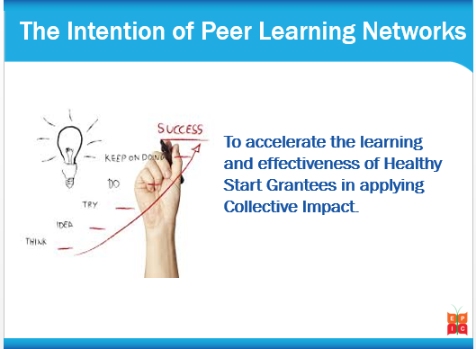Through the Healthy Start EPIC Center, six Peer Learning Networks (PLNs) are being established to accelerate the learning and experience of Healthy Start Grantees in the application of Collective Impact to achieve its mission and goals. Initially, six Healthy Start Peer Learning Networks (PLNs) will be formed. Each The Peer Learning Network will be co-facilitated by a Healthy Start Grantee Lead and EPIC Center Technical Consultant. It is anticipated that the majority of the 101 Healthy Start Grantees will participate in PLNs to support the development of their own Collective Impact implementation plans.

The Healthy Start EPIC Center believes that the effective application of Collective Impact will be accelerated by investing in Peer Learning. Because Collective Impact is still very much an emerging field of practice, our shared understanding of it as a framework and approach will continue to be refined and deepened by the insights share by grantees through their own experiences with its implementation. The rapid popularity of Collective Impact has generated some concern that many are simply re-branding their traditional approaches to community change as Collective Impact efforts without committing to embracing the opportunities to think and work differently that an authentic commitment to Collective Impact requires.

An evaluation of Tamarack’s own experience implementing a Collective Impact initiative – Vibrant Communities Canada – affirmed the importance of learning – and a learning infrastructure – to accelerate the impact of work on complex community issues. This evaluation, ***Inspired Learning***, concluded that, *“There are clear benefits to establishing an interconnected architecture of supports in situations where the burden of learning is high. Peers from other communities can help organizations to innovate and to move more quickly in implementing new approaches and initiatives….The bottom line is that in the realm of complex issues and comprehensive efforts to mobilize learning and new approaches, the full suite of supports offered through VC was an essential ingredient in its ultimate success.”*

Continuous learning has also been identified as critical to the success of collective impact efforts. This was highlighted in FSG’s ***Evaluating Collective Impact Part I***, which states: “*In order for CI initiatives to be successful, their leaders must understand that collective impact is not a solution, but rather a problem-solving process.* *This process requires leaders to remain keenly aware of changes in context, conditions, and circumstances; to embrace curiosity and seek opportunities for learning; to openly share information and observations with others; and, most importantly, to willingly adapt their strategies quickly in response to the ever-evolving environment. This is what it means to embrace continuous learning, which we believe is critical to CI success.”*

APPENDIX

Healthy Start Collective Impact Peer Learning Networks (CI-PLNs)

***What Is a Peer Learning Network and How Can It Benefit Healthy Start?***

A group who have a common interest in a topic.
Share best practices.
Create new knowledge.
Advance the work of their field.

"In the context of collective impact, continuous learning is as much a behavior and disposition as is is a philosophy and practice." Peer Learning Networks can also be thought of as Communities of Practice. Etienne Wenger, an expert in the field, defines Communities of Practice as, *“groups of people who share a concern, a set of problems, or a passion about a topic and who deepen their knowledge and expertise in this area by interacting on an ongoing basis.”* Communities of Practice offer *“a model for connecting people in the spirit of learning, knowledge sharing, and collaboration as well as individual, group, and organizational development.”*  Tamarack’s experience in Vibrant Communities affirmed the benefits of peer learning, which included:

* Translating valuable strategies in multiple communities
* Helping communities to access the ideas and experience base of other communities
* Facilitating learning about specific challenges or issues, or new program or policy ideas
* Providing an ongoing reinforcement of VC principles and contributing to a shared identity that brought broader recognition and legitimacy to the overall approach.

The intentional focus on learning offered by Peer Learning Networks aligns well with Collective Impact. The importance of continuous, strategic learning was highlighted in FSG’s *Evaluating Collective Impact,* which states, *“In the context of collective impact, continuous learning is as much a behavior and disposition as it is a philosophy and practice. For those working in complex, dynamic, and emergent environments such as CI, learning involves the use of data and insights from a variety of information-gathering approaches to inform decision making about strategy. Strategic learning occurs when organizations or groups integrate data and evaluative thinking into their work and then adapt their strategies in response to what they learn.”*

Tamarack’s own experience implementing the Pan-Canadian initiative, Vibrant Communities, also highlighted the value and necessity of peer learning. An independent evaluation of Vibrant Communities, concluded that, *“When dealing with complex issues, learning the ropes and enabling feedback loops are a necessary part of the intervention. In the complex, how you engage is part of the nature of the intervention. Capacity is not just about content, it is about learning how to learn in the context of the issue you are addressing.”*

The implementation of Peer Learning Networks is new to the Healthy Start EPIC Center and we anticipate that we will learn a tremendous amount from our co-facilitators and PLN participants as this first phase of implementation unfolds. We welcome feedback and suggestions throughout this journey so that we can continually refine and enhance this tool kit and process.

***How Is a Peer Learning Network Different from a Workshop or Webinar?***

While Peer Learning Networks, workshops and trainings share a common focus on knowledge and capacity-building, there are some important distinctions between them. For one, Peer Learning Networks are “learning communities” and as such, they typically meet regularly over an extended period of time. Successful Peer Learning Networks establish rituals and rhythms designed to cultivate trust, relationships and understanding among participants. Another important distinction is the emphasis on dialogue and learning together that dominates the design of peer learning. Where workshops often emphasize the leader imparting knowledge to participants, leadership within Peer Learning Networks is typically shared, and knowledge and learning is co-created through the dialogue and problem-solving that participants engage in together.

|  |  |
| --- | --- |
| **Peer Learning Networks**  ***Focus on Learning*** | **Training & Workshops**  ***Focus on Teaching*** |
| Participants and facilitators learn together | Leader/Facilitator provides information and knowledge to participants |
| Answers are co-discovered through reflection and dialogue | Answers are known and shared |
| Have a commitment to meet regularly | Typically a single, one-off experience |
| Agenda is outlined in advance but adapted by participants’ needs and insights | Agenda is set and predetermined |
| Building trust and mutual support amongst participants is key | Relationships between and amongst participants not required |
| Leadership for the group is shared | Workshop Leader is responsible for the tone and interactions of the group |
| ***Facilitator is “a guide from the side”*** | ***Facilitator is “a sage on the stage”*** |

The Healthy Start Peer Learning Journey

***An Overview of the Healthy Start Peer Learning Network Process***

Image showing stages of CI TA plan and process with photos.

Stage 1: Planning (Feb 2015)
Stage 2: Training and Grantee Input (Feb/March 2015)
Stage 3: ToT (March 2015)
Stave 4: Launch (Apr/May 2015)
Stage 5: Sharing (Nov/Dec 2015)
Stage 6: Next steps (Dec 2015)Between April/May – December 2015 each Peer Learning Network will meet by phone 6-8 times for 90 minutes per session. Each session will build upon the previous one and focus on a particular aspect of Collective Impact.

Relevant content (resources, tools etc.) drawn from the tool box (and other sources) will be presented during each call but the emphasis will primarily be on encouraging reflection, dialogue and problem-solving amongst participants and opportunities to provide mutual support.

We anticipate that the familiarity and experience with the various topic areas covered by the PLN discussions will vary amongst participants. Those who have more experience and familiarity with a particular topic will be encouraged to share their experiences and advice, while those who are less familiar will be encouraged to bring “a beginner’s mind”, asking questions; and testing new ideas with their colleagues.

Because the establishment of Peer Learning Networks is new for the Healthy Start EPIC Center, we fully anticipate that the content and design of the process and the **Healthy Start Collective Impact Implementation Tool Box** will evolve and be adapted in response to input and feedback from participants and co-facilitators as well. Such feedback is needed and welcome. Feedback, comments and suggestions about the tool box and the Peer Learning Network process can be forwarded via email to [**Kimberly Bradley**](mailto:KBradley@zerotothree.org), Senior Technical Assistance Specialist, Healthy Start EPIC Center via email at [**KBradley@zerotothree.org**](mailto:KBradley@zerotothree.org) or via phone at **202-857-2988.**

Outline of 8 discussion calls with focus and intent.


The graphic above provides an overview of the proposed focus for each of the 8 proposed PLN Discussion Calls to be held between April/May and December 2015.

***Healthy Start Peer Learning Network Deliverables***

Key Deliverables:
1. Each grantee will present a 1 year CI Implementation Plan using a template that is provided
2. Each Peer Learning Network will: Document and share highlights, insights and learnings from their network, share any resources and tools developed by their netowrk, and identify learning needs and supports for the next phase of work.While there is an emphasis on process and ensuring that Peer Learning Networks establish mutually supportive relationships to capture, share and accelerate learning in applying Collective Impact to their work, each grantee, and Peer Learning Network is responsible for the following deliverables:

* **Healthy Start grantees** will be responsible for using the tools and resources of this tool box to develop and present a Year I Collective Impact Action Plan by December 2015 (see **SECTION 7 – Bringing It All Together** of this tool box for the Healthy Start Year I Collective Impact Action Plan Framework) and,
* **Peer Learning Networks** will be responsible for:
  1. **Documenting their learnings** –Insights, AHAs, and challenges, from the PLN calls will be captured and shared;
  2. **Sharing resources and tools** – PLN Participants can share their own resources and tools to add to this CI Implementation Tool Box;
  3. **Identifying future learning needs** – As the Year I CI Action Plans are completed, PLNs will be asked to identify future learning needs to support the next phase of their work; and,
  4. **Providing feedback on this process** – PLNs will be asked to give feedback to continue to refine this Peer Learning Network process and the **Healthy Start Collective Impact Implementation Tool Box**.

***The Role of Healthy Start Peer Learning Network Co-Facilitators***

A Process focus:
Accelerates trust and mutual support
Creates a safe learning environment
Encourages learning and taking risk
Established a predictable rhythm

A product focus:
Emphasizes taking purposeful action
Achieves specific deliverables within a particular timeframe
Encourages reflection on past actions
Captures and shares its insights and knowledgeThe PLN Co-facilitators convene and host their Peer Learning Network dialogues, and are responsible for tailoring and adapting the proposed agendas for each call to best meet the unique learning needs of their participants. Co-facilitators should encourage their PLN participants to share leadership and responsibility for the work of the PLN. PLN members should also be encouraged to connect and support one another between calls if possible.

Co-facilitation teams must pay particular attention to ensuring that their Peer Learning Networks find a healthy balance between attending to process – so that strong, mutually supportive relationships, learning and co-mentoring develop among Network members – and simultaneously attending to the Collective Impact content, and, ultimately, that each participant is applying their new knowledge in developing a Year I Collective Impact Action Plan.

The following supports have been put in place to support co-facilitation teams in their role:

1. **A** [**Train-the-Trainer Orientation Webinar**](https://jsi.webex.com/jsi/lsr.php?RCID=3a6ffca2425c4b0ebb3b08c7ca061f46) held on March 20th, 2015 offered co-facilitators an initial orientation to the Peer Learning Network process and resources. A recording of the webinar is available online [here](https://jsi.webex.com/jsi/lsr.php?RCID=3a6ffca2425c4b0ebb3b08c7ca061f46) and a copy of the slide deck from the webinar can be found on [healthystartepic.org](http://healthystartepic.org).
2. **A Train the Trainer Workshop** is being held on March 26th & 27th, 2015. It will build upon the information shared in the Webinar and provide co-facilitators with an orientation to the Collective Impact Implementation Tool Box and provide an opportunity for co-facilitators to develop their plan for convening and offering leadership to their Peer Learning Network. The Workshop will encourage co-facilitators to share ideas with each other and benefit from each other’s thinking.
3. **A Healthy Start Collective Impact Implementation Tool Box** – This resource includes information, worksheets and resources to support Healthy Start Grantees to engage their Community Action Networks (CANs) and other community partners to work collaboratively together applying the lens of Collective Impact to help them achieve their goals.
4. **Two Group Coaching Calls with Tamarack** – Between April and December 2015 the PLN Co-Facilitators will have the opportunity to participate in two coaching calls with Liz Weaver and Sylvia Cheuy of the Tamarack Institute.
5. **One Individual Coaching Call with Tamarack** – In addition to the group coaching calls with Tamarack, each co-facilitation team also has the opportunity to engage the staff of Tamarack in one, individual coaching call focused on the work of their Peer Learning Network.

Building Your Peer Learning Network

**Overview**

Here you will find an outline, tools and resources to assist Healthy Start Peer Learning Networks (PLN) and their co-facilitators to convene and host the discussions and strengthen mutual understanding and trust between participants. The benefits of peer learning include:

* + **Accelerating** knowledge acquisition
  + Allowing concepts to be explored in **greater depth**
  + Linking **theories and concepts** to personal **experience and actions**
  + Surfacing assumptions and **challenges paradigms**
  + Supporting **transformations** in individual and collective learning

The primary role of co-facilitators is to support participants in their learning process through dialogues that enhance and deepen the experience and accelerate the acquisition--and sharing – of knowledge. Below are some tips for this role:

* **Let wisdom emerge** – You are not expected to be an expert. Your role is to foster a supportive learning environment by:
  + Inviting self-reflection, exploration, and questioning
  + Encouraging dialogues that enable the group’s collective wisdom to emerge.
  + **Foster inclusivity** –Create a space for all to express their opinions openly. Ensure all in the group have an opportunity to speak and share.
  + **Ask provocative questions** – Encourage deeper exploration that supports learners to transform their current thinking, challenge their paradigms and shift their mindsets.

* + **Know the exercises** - Familiarize yourself with the dialogue questions and activities so that you are focused and engaged with the participants.

**Tools for Building Your Peer Learning Network**

1. **Peer Learning Network Road Map** – This provides and overview of the PLN Journey, including the focus and intent of each call.
2. **PLN Discussion Call Agenda Plan Template** – This tool can be used by co-facilitators to plan and confirm their approach for each PLN call.
3. **PLN Call Highlights & Summary Log** – This tool can be used by co-facilitators and their PLNs to capture and record key content from each Discussion Call.
4. **Discussion Guidelines for Good Dialogue** –These guidelines by Peerspirit offer a good starting point for discussion around the agreements each PLN wants to commit to regarding how they will work, learn and be together.
5. **Generative Star Relationship Tool** –This tool is a framework for assessing the generative potential of working relationships. The model highlights the four primary factors needed to foster generative relationships.

**Resources for Going Deeper**

1. [**Community of Practice Design Guide**](http://tamarackcci.ca/files/communities_of_practice_design_guide.pdf)by D. Cambridge, S Kaplan and V. Suter – This article provides a good overview and rationale for how to build effective Communities of Practice or peer learning communities.
2. [**Supporting Pioneering Leaders as Communities of Practice**](http://www.margaretwheatley.com/articles/supportingpioneerleaders.html)by Margaret J. Wheatley – This paper makes the case for why, establishing peer learning networks is particularly critical for leaders on the forefront of implementing a new approach.
3. [**Gamestorming: A Playbook for Innovators**](http://www.gamestorming.com/) – Good facilitation techniques and “games” are important for encouraging groups of people to think together, differently. This website (also a book) and website provide many proposed facilitation exercises, each well-described and easy to replicate.
4. [**Campus for Communities**](http://www.campusforcommunities.ca) – This website provides a number of valuable facilitation tools to support community engagement.
5. [**Liberating Structures**](http://www.liberatingstructures.com/) – This website (and book) is a treasure trove of 33 different methods that can be used to improve how people think and work together.

**Peer Learning Network Discussion Call Agenda Plan**

| **Call #:** | **Focus & Intent:** |
| --- | --- |
| **Check-In: (10 minutes)** | |
| **Content Overview: (15 minutes) Tools and Resources to Use; Points to Highlight; Examples to Share** | |
| **Participant Dialogue: (50 minutes) Dialogue Questions; Problem or Issue to Solve** | |
| **Suggestions for Action: (10 minutes) What can participants do between calls? ID opportunities to support one another** | |
| **Highlights for Next Call: (5 minutes) Date & Time; Focus; Participant Roles** | |

**PLN Discussion Call Summary & Highlights**

| **Call #:** | **Focus & Intent:** |
| --- | --- |
| **Conversation Themes:** | |
| **Participant Insights & Learning:** | |
| **New Questions:** | |
| **Emerging Needs:** | |

Suggested Guidelines for Good Dialogue

**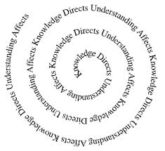**

**Circle: A Container for Conversation**

* Creates a safe space for exploring new territory
* Grows trust and belonging through agreements and practices
* Builds a common experience and language.
* “Seeks agreement" on what to do together

***The goal is to create a conversation that helps people to think together.***

*Peerspirit* Circle Guidelines for Good Dialogue

**Three Principles**

In our dialogues:

1. Leadership is rotating
2. Responsibility is shared
3. Centre is held by the reliance on spirit

**Three Practices**

We agree to:

1. Listen with attention
2. Speak with intention
3. Contribute to the well-being of the group

**Four Agreements**

We commit to:

1. Keeping the stories we share in circle confidential
2. Listening with compassion and curiosity
3. Asking each other for what we need and offering what we can
4. Pausing, from time to time, to re-gather our thoughts or focus

Source: [**Peerspirit**](http://www.peerspirit.com) - Christina Baldwin and Ann Linea

The Generative Star Relationship Tool

For more please see [Liberating Structures’ Generative Relationships STAR](http://www.liberatingstructures.com/26-generative-relationships-st/)

**EXERCISE DESCRIPTION:**

Generative Relationships are relationships that produce “*new sources of value that cannot be foreseen in advance.”* Generative relationships are particularly valuable in complex, rapidly changing environments because they draw from multiple perspectives and therefore provide a better assessment of what is happening.

**The Generative Relationship STAR Too**l is a framework for assessing the generative potential of working relationships. The model highlights the four primary factors needed to foster generative relationships using the acronym STAR:

• **Separateness or Differences** – For a team to work productively there must be a diversity of skills and perspectives. This enables them to collectively see things that individually they may not.

• **Tuning** (deeply listening, reflecting and sense-making together) - Teams need opportunities to talk and listen, reflect and learn together.

• **Action Opportunities** – Teams need to take action together, co-creating something new. They need a shared focus or purpose that unites them.

• **Reasons to Work Together** – There must be a mutual benefit for individuals to collaborate on a project.

**The Generative STAR Too**l can be used to guide the composition of new work teams. It can also be used by newly forming teams to:

* Explore their diversity and make their collective strengths and challenges in working together explicit.
* Identify strategies to ensure that their group reaches its generative potential, so that their work together reflects something that is far greater than the sum of their individual parts.

**EXERCISE HOW-TO:**

1. Participants individually assess where the team is in regard to each of the four elements. (5 min.)

* **S** -How diverse are we as a group? Do we draw out our diverse perspectives among members?
* **T** - How well are we in tune with one another?
* **A** - How much do we act together?
* **R** -How important is it that we work together? How clear is our purpose?

1. Participants place a dot along each compass point, and then talk about their placements, looking for consensus and differences. (5 min.)
2. The group discusses what type of results are generated by the pattern of interaction they have identified (e.g., high Tuning + no Action = we get along well but accomplish little, high Action + low Tuning = routine results with no innovation, high Tuning + high Separateness + high Action + low Reason = many false starts, etc.). (5 min.)
3. In small groups, brainstorm action steps to boost elements that need attention. (5 min.). Then, the whole group assembles a list of action steps and decides “What first steps can we take right now?” (5 min.)

**EXERCISE DEBRIEF:**

Possible debrief questions include:

* What does this exercise reveal about the generative potential of our team?
* What strategies do we think can help ensure that our team reaches its generative potential?

**The Generative STAR Tool**

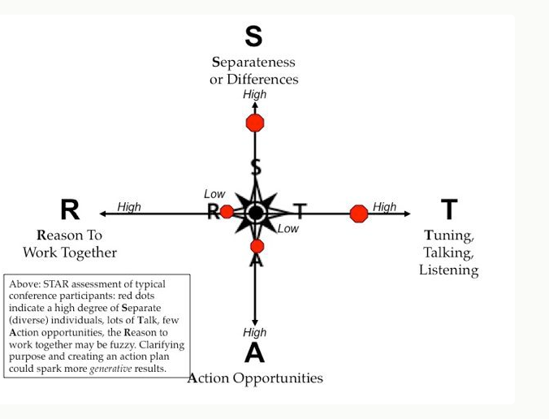

**Interpreting Results:**

* High Tuning + no Action = we get along well but accomplish little,
* High Action + Low Tuning = routine results with no innovation,
* High Tuning + High Separateness + High Action + Low Reason = many false starts